 | Yough Cougar Rocketry Team  Student Launch Initiative  Critical Design Review  January 22, 2008
Table of Contents Page

Summary of CDR Report 2
Team Summary 2
Launch Vehicle Summary 2
Payload Summary 2
Changes made since PDR 3
Vehicle Criteria 3
Design and Verification of Launch Vehicle 3
CADD drawings of Dorothy II 4
Suitability of Fin Shape 5
Proper Use of Materials 5
Recovery Subsystem 6
Missions Performance Predictions 7
Graph of Overall Simulation Data 9
Graph of Thrust Curve 9
Graph of Altitude 10
Component Weights 10
¼ Scale Launch Results 12
RockSim diagram with CG and CP 12
Payload Integration 13
Launch Concerns and Operations Procedures 13
Safety and Environment (Vehicle) 16
Payload Criteria 17
Testing and Design of Payload Experiment 17
Review the Design at System Level 18
Assembled Electronics Board 21
Payload Concept Features and Definition 22
Science Value 23
The Reason for Whirly Bird Development 23
Summary of the Scientific Payloads Mission 24
Test and Measurement 24
Variables and Controls 24
Relevance of expected data, accuracy / error analysis 24
Experiment Process Procedures 25
Safety and Environment (Payload) 25
Activity Plan 27
Budget Plan 27
Timeline 29
Outreach 32
Conclusion 34

I). Summary of CDR Report

“Project Dorothy”

Yough High School Rocketry Team
919 Lowber Road
Herminie, PA 15637
724 – 446 – 5520 ext. 2015

Student Participants

- Bickerstaff, Amy – YHS Senior, Vehicle Design, Team Lead, and Schedule Manager
- Wiley, Ashley – YHS Junior, NAR & FAA Regulations and Flight Control, Payload
- Abbott, Stephanie – YHS Sophomore, Safety Operations Manager
- Sarosinski, Josh – YHS Sophomore, Hazardous Materials and Environmental Concerns
- Bowser, Alicia – YHS Senior, Assistant – Not participating in the trip to Huntsville

Administrative Staff Members

- Donald L. Gilbert, Jr. – Physics and Gifted Teacher, TARC coordinator
  - Phone: (724) 446 – 5520 ext. 2015
  - Email: gilbertd@yough.k12.pa.us

Main NAR, TRIPOLI and Other Field Specific Mentors

- Ernest Walters – TRIPOLI Pittsburgh – Level 3 Certified
  - Uniontown, PA
  - Phone: (724) 439 – 9062
- Eric Haberman – TRIPOLI Pittsburgh – Westinghouse Corporation
  - West Newton, PA
  - Phone: (412) 337 – 5799
- Joe Pscolka – TRIPOLI Pittsburgh – Level 3 Certified
  - Washington, PA
  - Phone: (724) 945 – 6605
- Mike Uschak – Electronic Systems
  - Latrobe, PA
  - Phone: (724) 537 – 8798

Launch Vehicle Summary
- Four Inch fiberglass airframe, 124 inches in length, approximately 530 ounces in mass
- Aerotech L1150 or Animal Motor Works L900RR motor to be used
- Dual deployment, dual altimeter with four ejection charges, 18 inch drogue, 60 inch main chute
- 1 ½ inch rail size to be used

Payload Summary
- Crepe paper wrapped paint balls to mimic maple tree seed pods for dispersion
- Electronic data ball with temperature, pressure, ultraviolet, and humidity sensors
II). Changes made since PDR

Changes to Vehicle Criteria

A possible motor change has been made to account for the increased mass of the sabot ejection system. An Aerotech L1150 or Animal Motor Works L900RR appears to yield better results in Rocksim.

Changes made to Payload Criteria

A sabot ejection system will be utilized to expend the whirly birds and main parachute. The data ball is currently in question as locating the required parts have not been successful.

Changes made to the Activity Plan

The outreach has been modified due to the team being unable to work with the middle school students. Outreach will now be held in the community with Starhawk rockets being given to children. A rocket fair will be held in either March or April depending on the weather conditions.

III). Vehicle Criteria

Design and Verification of Launch Vehicle

The mission of “The Making of the Whirly Birds” is to construct a launch vehicle containing a scientific payload that will achieve an above ground level altitude of 5280 feet (one mile) and safely deploy the payload as well as return to ground level to be reused.

The requirements of the launch vehicle are to liftoff from the launch pad without yawing drastically in any wind conditions to unsure nearly vertical flight characteristics with a motor of sufficient thrust to achieve the above ground level altitude of one mile while the G-Wiz LC 800 altimeters fire the two drogue parachute charges upon apogee and the two main charges at 800 feet above ground level to ensure safe descent rates in order to minimize or prevent any damage to the launch vehicle.

Success of the launch vehicle mission will be to analyze the altimeter data to verify the above ground level altitude from each of the G-Wiz LC 800 altimeters (2), monitor visually the successful deployment of the drogue and main parachutes at the desired altitudes as well as the firing of the ejection charges, and inspect the launch vehicle for damage upon retrieval to the earths surface.

Launch vehicle construction began on December 3rd, 2007. The design phase has been completed with modifications made to the original Dorothy design from SLI 2007. Unfortunately, Mr. Eric Haberman did not complete work on the nosecone and fiberglass airframe by December 3rd. These items are scheduled for completion on January 27th, 2008. The nosecone and fiberglass tubing was previously purchased through Mr. Ken Allen, a retailer for Performance Rocketry components. Mr. Haberman also verified the proper sizing of parts at the time of manufacture, which was on December 1st, 2007. These measurements were checked against those of the RockSim data on December 12th, 2007. Operation of the launch vehicle is scheduled for testing no later than February 23rd, 2008. A major review of the design and its components will occur after the launch of the competed vehicle. Updates will appear in the Flight Readiness Review.

Dorothy II is designed using the same data from her big sister Dorothy I from SLI 2007. The length of the launch vehicle is to ensure more than adequate stability characteristics of more than 4 calibers. Testing of smaller scale rockets, even on low thrust motors showed nearly no yaw (weather cocking) even in moderate to high wind conditions. The through the wall fin design ensures that the fins will remain in the structure during the entire range of the flight. Fiberglass tubing was selected for its lightweight and low cost, as well as workability with hand tools and small power equipment. The G-Wiz LC 800 was selected as the altimeter due to its ease of use and dual deployment features on multiple batteries. SkyAngle parachutes were chosen due to their proven reliability at other high power rocketry events. The sizes were determined after discussion with level II and level III Tripoli members.

CADD drawings created by Eric Haberman show the Center of Pressure and Center of Gravity as well as locations for vent holes and linear dimensions.

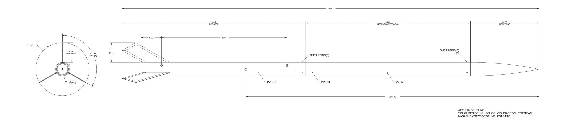
The assembly can be seen in multiple sections with the components in view.

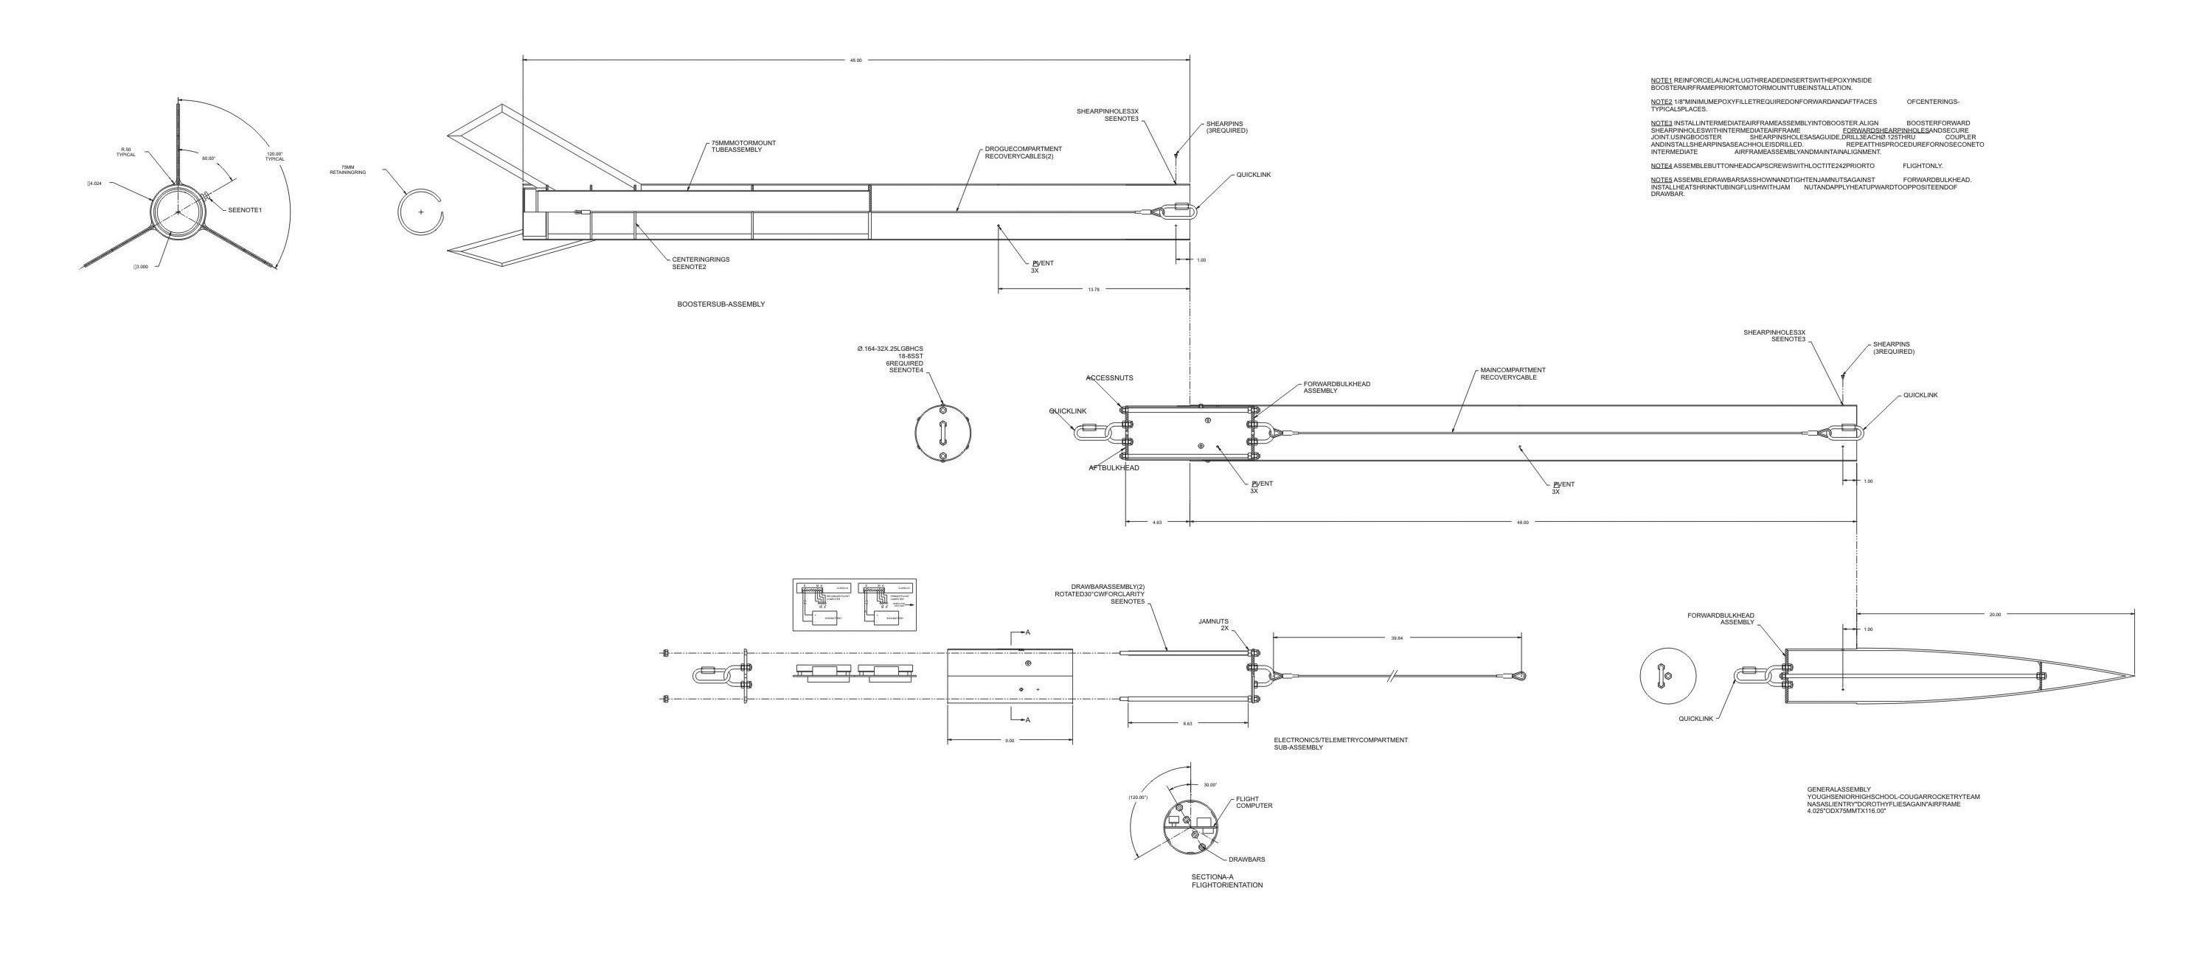

The assembled Dorothy II with the internal parts shown.
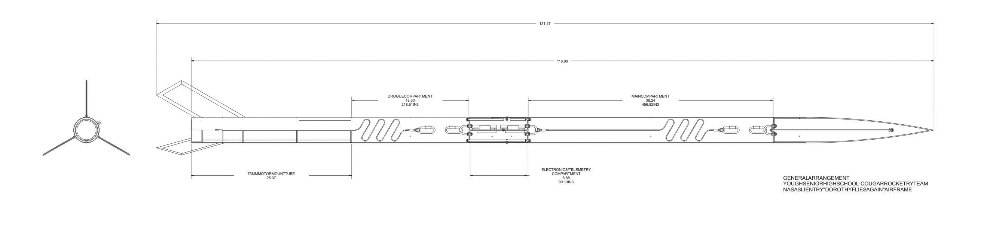
Suitability of Fin Shape

The fin shape of Dorothy II is very suitable for this particular mission. Due to the length of Dorothy II, fins of a large surface area are not required since the center of gravity if many calibers forward of the center of pressure. Multiple fin shapes were attempted using Rocksim and none seemed to be as aesthetically pleasing while maintaining the desired CP. Non-uniform beveling of the leading edge of the fins has also been a topic of discussion to cause Dorothy to spiral upward, therefore making very stable. They also help her resist wind and fly a very straight path. It is especially useful for this mission since the objective of Dorothy II is to fly a mile high in the air, where wind speeds can reach higher levels.

Proper Use of Materials

For the main airframe, the team has selected four-inch fiberglass G12 tubing. The group chose the four-inch fiberglass tubing because of its functional ability for the payload design and it’s structural rigidity. Bulk plates for the electronics bay are cut from ¼ inch G10 fiberglass to ensure a quality mounting point for the U-bolts which are attached to stainless steel braided wire. This wire is then attached to the engine mount in the aft section of the airframe. Kevlar chord attaches the forward compartment with the whirly birds and main parachute. All the fastening hardware selected is of stainless steel materials so that the structural integrity is maximized and the probability of stress fractures is minimized. Ball bearing swivel clips attach to any area where entanglement is not desired. The fins area a through the wall design, constructed of .1875-inch (3/16 inch) G-10 fiberglass. G-10 fiberglass was highly recommended by many of the TRIPOLI high power rocketry members, therefore being an obvious choice for this project due to its high tensile strength and breaking points. To ensure proper assembly, local high power rocket mentors, Ernie Walters, Eric Haberman, and Joe Pscolka, will be overseeing the complete building process. Having this supervision enables the team to design, construct and test the rocket properly.

Assembly of Dorothy II begins with three fin slots being cut into one section of the 48-inch fiberglass tubing. The motor mount, constructed of a 75-millimeter fiberglass tube, with three G10 centering rings will be inserted and epoxied into the main airframe. Before the epoxy sets, the fins are inserted into the slots where they will lock into the centering rings of the motor mount. Epoxy will then be injected into the slots so that the epoxy will be in contact with the motor mount and the interior of the airframe. Once these parts fit properly, a jig designed to hold the fins in a perfect 120-degree alignment will be placed onto the airframe. A final bead of epoxy will then be placed along the fin and airframe exterior.

Recovery Subsystem

The suitable parachute size for Dorothy II is 60 inches. The attachment scheme of Dorothy II’s recovery subsystem is a 3/16 inch Kevlar chord attached to a ball bearing swivel clip which are attached to a 1/8 inch braided stainless steel cable.

Deployment Process: Gunpowder Equations

PSI by Airframe Diameter and Desired Force Airframe
Diameter 100 Pounds 150 Pounds 200 Pounds 250 Pounds
2.6" 19 psi 28 psi 38 psi 47 psi
4.0" 8 psi 12 psi 16 psi 20 psi
6.0" 3.5 psi 5.3 psi 7.0 psi 8.8 psi
7.5" 2.3 psi 3.4 psi 4.5 psi 5.7 psi

The table shows that smaller diameter airframes may need a higher pressure than larger diameter airframes.

Once you've selected a desired force (150, 200 or 250 pounds) on the nose cone, determine the psi that will produce that force. For example, 16 psi will put 200 pounds of force on the nose cone of a 4" diameter rocket.

Now determine the amount of BP to produce the desired pressure. An equation is shown below.

C * D * D * L = grams of BP

* C - one of the values listed below
0.002 = 5 psi
0.004 = 10 psi
0.006 = 15 psi
0.0072 = 18 psi
0.008 = 20 psi
* D = airframe diameter, in inches
* L = length of the cavity to be pressurized, in inches

The Yough Cougar Rocketry team has calculated that Dorothy II will require less than 1.0 grams of black powder to successfully eject the parachute and payload.

As of now, Mr. Eric Haberman has the fiberglass tubing of Dorothy to notch the fins. So we are unable to do the ejection charges and electronics tests that are needed in the CDR.

Safety and Failure Analysis

If the recovery subsystem fails, the following safety precautions will be followed:

Before the rocket launches
- Failure to arm the ejection charge systems
- Accidental launch before spectators are at a safe distance
- Personnel could drop or damage rocket causing system failures
To prevent such things from happening
- Have more than one person overlooking preparation of launching
- Make sure that everyone is in the safety zone before launch of the rocket
- All personnel need to be aware of the surroundings
- Store rocket in a secure location

During the rocket launch
- Personnel could lose visual contact with the launch vehicle
- Rocket could have a malfunction resulting in shrapnel hitting someone
To prevent such things from happening
- Have more than one person watching the rocket and pin-pointing a location for landing
- Watch the rocket at all times and if debris or shrapnel flies, get undercover
- Keep and eye on where any debris and shrapnel land in order to recover and pick up to prevent environmental harm

Mission Performance Predictions

The mission of “The Making of the Whirly Birds” is to construct a launch vehicle containing a scientific payload that will achieve an above ground level altitude of 5280 feet ( one mile ) and safely deploy the payload as well as return to ground level to be reused.

Simulation results

Engine selection
[L1150-None]
Simulation control parameters
Flight resolution: 800.000000 samples/second
Descent resolution: 1.000000 samples/second
Method: Explicit Euler
End the simulation when the rocket reaches the ground.
Launch conditions
Altitude: 100.00000 Ft.
Relative humidity: 70.000 %
Temperature: 60.000 Deg. F
Pressure: 29.9140 In.
Wind speed model: Custom speed range
Low wind speed: 10.0000 MPH
High wind speed: 10.0000 MPH
Wind turbulence: Fairly constant speed (0.01)
Frequency: 0.010000 rad/second
Wind starts at altitude: 0.00000 Ft.
Launch guide angle: 0.000 Degrees from vertical
Latitude: 37.000 Degrees
Launch guide data:
Launch guide length: 60.0000 In.
Velocity at launch guide departure: 48.9323 ft/s
The launch guide was cleared at : 0.251 Seconds
User specified minimum velocity for stable flight: 43.9993 ft/s
Minimum velocity for stable flight reached at: 50.2054 In.
Max data values:
Maximum acceleration:
Vertical (y): 262.014 Ft./s/s
Horizontal (x): 3.788 Ft./s/s
Magnitude: 264.590 Ft./s/s
Maximum velocity:
Vertical (y): 673.7682 ft/s,
Horizontal (x): 0.0000 ft/s,
Magnitude: 677.1859 ft/s
Maximum range from launch site: 847.03481 Ft.
Maximum altitude: 5809.27100 Ft.
Recovery system data
P: Drogue Parachute Deployed at : 19.125 Seconds
Velocity at deployment: 46.6175 ft/s
Altitude at deployment: 5809.27099 Ft.
Range at deployment: -847.03481 Ft.
Time data
Time to burnout: 3.165 Sec.
Time to apogee: 19.125 Sec.
Optimal ejection delay: 15.960 Sec.

Component Weights

Nose cone Performance Rocketry - - , Material: Fiberglass
Nose shape: Hollow Ogive, Len: 23.0000 In., Dia: 4.0000 In. Wall thickness: 0.1250 In. Body insert: OD: 3.9000 In., Len: 4.0000 In.
CG: 17.0000 In. , Mass: 15.2384 Oz. Radius of gyration: 0.189288 (m) , 18.9288 (cm)
Moment of inertia: 0.0154785 (kgm^2) , 154785 (gcm^2)

Body tube Performance Rocketry - - , Material: Fiberglass
OD: 4.0000 In. , ID: 3.8750 In. , Len: 48.0000 In.
CG: 24.0000 In. , Mass: 36.7555 Oz. Radius of gyration: 0.354123 (m) , 35.4123 (cm)
Moment of inertia: 0.13067 (kgm^2) , 1.3067e+06 (gcm^2)

Tube coupler Performance Rocketry - - , Material: Fiberglass
Tube couple rod: 3.8750 In., Hole #1: : 95.2500 In. Len: 9.0000 In. Location: 43.2500 In. From the front of Body tube
CG: 4.5000 In. , Mass: 6.9137 Oz. Radius of gyration: 0.0744297 (m) , 7.44297 (cm)
Moment of inertia: 0.0010858 (kgm^2) , 10858 (gcm^2)

Parachute b2 Rocketry - SkyAngle - CERT-3 Large, Material: 1.9 oz. Ripstop Nylon (SkyAngle)
1 parachute, Shape: Round Dia: 82.7000 In., Spill hole: 0.0000 In.
CG: 0.0000 In. , Mass: 10.5822 Oz. Radius of gyration: 0.103079 (m) , 10.3079 (cm)
Moment of inertia: 0.00318761 (kgm^2) , 31876.1 (gcm^2)

Upper Electronics Bay Bulkhead Performance Rocketry - BH-3.90 - 3.90 in. Bulkhead, Material: G10 fiberglass
BulkheadOD: 3.9000 In., Len: 0.2500 In. Location: 42.7500 In. From the front of Body tube
CG: 0.1250 In. , Mass: 3.2890 Oz. Radius of gyration: 0.0248607 (m) , 2.48607 (cm)
Moment of inertia: 5.76284e-05 (kgm^2) , 576.284 (gcm^2)

Nosecone Bulkhead Performance Rocketry - BH-3.90 - 3.90 in. Bulkhead, Material: G10 fiberglass
BulkheadOD: 3.8750 In., Len: 0.2500 In. Location: 3.0000 In. From the front of Body tube
CG: 0.1250 In. , Mass: 3.2470 Oz. Radius of gyration: 0.0247022 (m) , 2.47022 (cm)
Moment of inertia: 5.61688e-05 (kgm^2) , 561.688 (gcm^2)

Upper Payload Canister Bulkhead Performance Rocketry - BH-3.90 - 3.90 in. Bulkhead, Material: G10 fiberglass
BulkheadOD: 3.9000 In., Len: 0.2500 In. Location: 18.0000 In. From the front of Body tube
CG: 0.1250 In. , Mass: 3.2890 Oz. Radius of gyration: 0.0248607 (m) , 2.48607 (cm)
Moment of inertia: 5.76284e-05 (kgm^2) , 576.284 (gcm^2)

Lower Payload Canister Bulkhead Performance Rocketry - BH-3.90 - 3.90 in. Bulkhead, Material: G10 fiberglass
BulkheadOD: 3.9000 In., Len: 0.2500 In. Location: 35.0000 In. From the front of Body tube
CG: 0.1250 In. , Mass: 3.2890 Oz. Radius of gyration: 0.0248607 (m) , 2.48607 (cm)
Moment of inertia: 5.76284e-05 (kgm^2) , 576.284 (gcm^2)

Whirly Birds - Custom, Material:
CG: 0.0000 In. , Mass: 32.0000 Oz. Radius of gyration: 0 (m) , 0 (cm)
Moment of inertia: 0 (kgm^2) , 0 (gcm^2)

Altimeter with batteries G-Wiz - - , Material: Custom
CG: 0.0000 In. , Mass: 2.4692 Oz. Radius of gyration: 0 (m) , 0 (cm)
Moment of inertia: 0 (kgm^2) , 0 (gcm^2)

ExtraWeight G-Wiz - - , Material: Custom
CG: 0.0000 In. , Mass: 64.0000 Oz. Radius of gyration: 0 (m) , 0 (cm)
Moment of inertia: 0 (kgm^2) , 0 (gcm^2)

Body tube Performance Rocketry - - , Material: Fiberglass
OD: 4.0000 In. , ID: 3.8750 In. , Len: 48.0000 In.
CG: 24.0000 In. , Mass: 36.7555 Oz. Radius of gyration: 0.354123 (m) , 35.4123 (cm)
Moment of inertia: 0.13067 (kgm^2) , 1.3067e+06 (gcm^2)

Fin set Fins by Eric Haberman - - , Material: G10 (PML 0.125)
CG: 5.0000 In. , Mass: 48.0001 Oz. Radius of gyration: 0.0891277 (m) , 8.91277 (cm)
Moment of inertia: 0.0108097 (kgm^2) , 108097 (gcm^2)

Parachute b2 Rocketry - SkyAngle - CERT-3 Drogue, Material: 1.9 oz. Ripstop Nylon (SkyAngle)
1 parachute, Shape: Round Dia: 21.8000 In., Spill hole: 0.0000 In.
CG: 0.0000 In. , Mass: 6.0000 Oz. Radius of gyration: 0.0331618 (m) , 3.31618 (cm)
Moment of inertia: 0.000187057 (kgm^2) , 1870.57 (gcm^2)

Rear Electronics Bay Bulkhead Performance Rocketry - BH-3.90 - 3.90 in. Bulkhead, Material: G10 fiberglass
BulkheadOD: 3.9000 In., Len: 0.2500 In. Location: 4.3750 In. From the front of Body tube
CG: 0.1250 In. , Mass: 3.2890 Oz. Radius of gyration: 0.0248607 (m) , 2.48607 (cm)
Moment of inertia: 5.76284e-05 (kgm^2) , 576.284 (gcm^2)

Launch lug Giant Leap - RG - ACME Rail Guide, Material: 1 in. tubular nylon
OD: 0.5000 In., ID: 0.4000 In., Len: 1.5000 In., Loc: 38.0000 In.
CG: 0.7500 In. , Mass: 0.0000 Oz. Radius of gyration: 0.0117392 (m) , 1.17392 (cm)
Moment of inertia: 1.06899e-11 (kgm^2) , 0.000106899 (gcm^2)

Launch lug Giant Leap - RG - ACME Rail Guide, Material: Polycarbonate
OD: 0.5000 In., ID: 0.4000 In., Len: 1.5000 In., Loc: 11.0000 In.
CG: 0.7500 In. , Mass: 0.0735 Oz. Radius of gyration: 0.0117392 (m) , 1.17392 (cm)
Moment of inertia: 2.8728e-07 (kgm^2) , 2.8728 (gcm^2)

LCX Altimeter with batteries G-Wiz - - , Material: Custom
CG: 0.0000 In. , Mass: 2.4692 Oz. Radius of gyration: 0 (m) , 0 (cm)
Moment of inertia: 0 (kgm^2) , 0 (gcm^2)

¼ Scale Launch Results

When we launched the quarter scale rocket on January 7th, the wind conditions were 10-14 mph and gust went up to 20 mph. The rocket ascended to a near vertical path. When it hit apogee, it weather cocked a slight bit and then the steamer deployed, causing it to flutter downward and unfortunately it landed on the school roof.

Using these results we predict that Dorothy II will rise into the troposphere traveling a relatively vertical path in moderate winds due to her higher thrust leaving the launch rail.

The stability margin of Dorothy II is 4.97 calibers. The Center of gravity is 79.41 inches from the nose and its location is shown in the diagram below. The center of pressure is 99.28 inches from the nose and its location is also shown (barely visible, hidden by gray color for motor) in the diagram below.

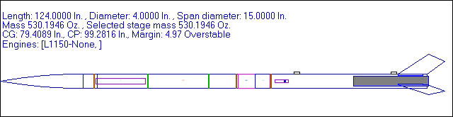

Payload Integration

Payload must be placed in the airframe securely as to avoid shifting during flight. Any movement could possibly damage the payload or disturb other sensitive electronics such as the altimeters and the subsequent ejection charges. If the payload is too rigidly secured however, then proper ejection my not take place. Repeated packing and testing of proper placement must be performed in order to verify proper system function.

The installation and removal of the payload section will be determined with the help of Mr. Ernie Walters and Mr. Joe Pscolka by using a sabot round that is going to encapsulate the payload to prevent the whirly birds from being singed and aid in the deployment process. The inside of the tube will be waxed to ensure the payload will have a smooth surface to be ejected from.

The payload is considered fairly simplistic, only if there are no electronic whirly birds put into the payload at the time of launch. If there are electronic whirly birds placed into the payload during launch, then the payload will be moderately difficult, figuring out the specifications of the small and intricate electronic sensors.

The compatibility of the payload section is to place the whirly birds into the black, flame retardant pouch, place the Kevlar rope through the one distinct hole in the pouch, where it gets tied off for placement in the payload area.

Launch Concerns and Operation Procedures

Launch Procedures

Launch Setup

Assembly Step | Assembly Personnel | Assembly Verification
Verify battery levels with voltmeter | Josh Sarosinski | Donald L. Gilbert, Jr.
Check that all wiring is secure and undamaged | Josh Sarosinski | Earnest Walters  Stephanie Abbott
Verify the systems are UNARMED | Josh Sarosinski | Earnest Walters  Stephanie Abbott
Verify the ejection systems are UNARMED | Josh Sarosinski  Ashley Wiley | Earnest Walters  Stephanie Abbott
Insert batteries into holders of the  electronics bay | Josh Sarosinski  Ashley Wiley | Earnest Walters
Verify all connections | Josh Sarosinski  Ashley Wiley | Earnest Walters  Stephanie Abbott
Signal the “ALL CLEAR” | Josh Sarosinski  Ashley Wiley | Range Safety Officer
Verify all connections before inserting payload pouches | Josh Sarosinski  Ashley Wiley | Earnest Walters  Donald L. Gilbert, Jr.
Insert payload into airframe | Amy Bickerstaff  Ashley Wiley | Earnest Walters  Stephanie Abbott
Join airframe tubes to coupler | Earnest Walters  Josh Sarosinski | Stephanie Abbott
Transport launch vehicle to launch pad | Earnest Walters  Josh Sarosinski | Stephanie Abbott  Donald L. Gilbert, Jr.
Secure launch vehicle to launch rail | Earnest Walters  Joe Pscolka | Amy Bickerstaff  Ashley Wiley

Recovery Preparation

Preparation Step | Assembly Personnel | Step Verification
Assemble ejection charge packets  ( High Risk – Use Extreme Caution | Earnest Walters | Josh Sarosinski  Stephanie Abbott
Place ejection charges into launch vehicle | Earnest Walters | Josh Sarosinski
Run wiring through launch vehicle to electronics bay | Josh Sarosinski  Ashley Wiley | Earnest Walters  Stephanie Abbott
Connect ejection charge wiring to altimeter ejection charge connections | Josh Sarosinski  Ashley Wiley | Earnest Walters  Stephanie Abbott
Arm ejection systems to verify continuity of systems via beeps from altimeter | Earnest Walters | Donald L. Gilbert, Jr.  Stephanie Abbott
DISARM ejection systems | Josh Sarosinski  Ashley Wiley | Earnest Walters

Motor Preparation

Preparation Step | Assembly Personnel | Step Verification
Assemble Animal Motor Works K780 | Earnest Walters | Joe Pscolka
Install K780 into launch vehicle airframe | Earnest Walters | Joe Pscolka

Igniter Preparation

Preparation Step | Assembly Personnel | Step Verification
Insert igniter into K780 motor | Range Safety Officer | Launch Safety Officer

Troubleshooting: System Failures

Before the rocket launches
- Eliminate all possibilities to forget to install devices of importance correctly
- Eliminate all possibilities to accidentally launch before everyone is safely behind safety shield
- Eliminate all possibilities to have anyone approach the rocket and cause injury to one’s self or the launch vehicle

To prevent such things from happening
- Have more than one person overlooking preparation of launch vehicle assembly
- Make sure that everyone is behind a safety shield or a safe distance from the launch pad as designated by the RSO before someone arms or launches the rocket
- Ensure that all personnel inside the launch area are aware of all activities and have necessary safety gear and emergency escape routes
- Have the launch vehicle in a secure area

During the rocket launch
1. During the launch, the launch vehicle could be lost if no one is tracking its path visually from the ground.
2. The launch vehicle could break apart or encounter an electronic malfunction resulting in catastrophic system failure causing multiple fiberglass fragments falling downward to the launch or spectator area.

To prevent such things from happening
- Have more than one person watching the rocket and pin-pointing a location for landing
- Watch the rocket at all times if debris falls from the launch vehicle. The person identifying any debris is to track its path to the ground and recover once the RSO has designated the area safe

Post Flight Inspection

Post Flight inspection will be preformed by the whole team individually, depending on what task have been assigned based on the tasks preformed prior to the launch of Dorothy II.

Safety and Environment ( Vehicle )

Stephanie Abbott is the Safety Officer for the Yough Cougar Rocketry Team.

Failure of the following launch vehicle items must be addressed to ensure safe flight and recovery of Dorothy II

Fins: In the event that a rocket fin would fall off, then the rocket could possibly fly uncontrollably in any direction. To prevent such an event, ensure that the fins are properly epoxied into the airframe and that the fin material is of appropriate strength to withstand the forces encountered.

Motor and Parachute- In the event that the motor doesn’t fire properly,
- If the motor does not have enough thrust then the rocket might not reach its potential apogee.
1a. Rocket could tip over and come down uncontrollably and hit the ground with immense speed and flutter around the ground
1b. If the motor does not give enough thrust, the parachute deployment could alter.
- If the parachute deployment is altered by motor malfunction, the parachute may not deploy; therefore, resulting in the rocket to fall uncontrollably.

Personal Hazards and Avoidance Procedures

Fiberglass in the eyes: wear safety goggles
Sawdust in the eyes: wear safety goggles
Cuts from fiberglass or sharp instruments: wear safety gloves and body protectors to cover and protect any area where skin shows
Headaches from fumes of paint: wear a breathing mask to cover the mouth and face to prevent inhalation of fumes, and to also paint in well ventilated area, such as a paint booth
Refer to MSDS sheets from the manufacture for special instructions
Tripping over wires: tape wires down to the ground, and if falling does occur, check for cuts and bruises to be bandaged if necessary. Sanitize all the affected areas with materials from First Aid Kit.
Other First Aid: Located first aid kit in a location convenient to all personnel in the working environment in case injury occurs
Additional personal hazards that can occur include,

Before the rocket launches
- Failure to arm the ejection charge systems
- Accidental launch before spectators are at a safe distance
- Personnel could drop or damage rocket causing system failures
To prevent such things from happening
- Have more than one person overlooking preparation of launching
- Make sure that everyone is in the safety zone before launch of the rocket
- All personnel need to be aware of the surroundings
- Store rocket in a secure location
During the rocket launch
- Personnel could lose visual contact with the launch vehicle
- Rocket could have a malfunction resulting in shrapnel hitting someone

To prevent such things from happening
- Have more than one person watching the rocket and pin-pointing a location for landing
- Watch the rocket at all times and if debris or shrapnel flies, get undercover
- Keep and eye on where any debris and shrapnel land in order to recover and pick up to prevent environmental harm

Environmental Concerns

If the rocket catches on fire then
- Wild-fire can occur if grass is dry enough
- Scorching of area around rocket can occur if grass is a little wet
- Items that fall off the rocket and are not recovered due to loss of visual tracking or paying attention could possibly be digested by animals causing illness

Things to do to prevent such things from happening

Many of the materials used in the construction of Dorothy II are made of biodegradable substances and has designated personnel to monitor any pieces that may detach from the airframe.

IV). Payload Criteria

Testing and Design of Payload Experiment

Review of the design at system level includes the following components:

Fins – Designed to maintain the rockets stability in order to prevent the payload from shifting during flight.
Motor mount and the motor retainer – Designed to keep the motor firmly attached to the airframe in order to limit vibrations, which could cause payload damage.
Altimeter – Designed to release the ejection charges at pre-determined altitudes in order for the payload to properly eject and perform the intended tasks.
Parachutes – The drogue parachute is designed to slow the rocket down after achieving maximum altitude thus beginning the main portion of recovery. The main parachute is designed to slow the rocket during the final phase of descent for a safe recovery and reuse. During this ejection, the scientific payload is also deployed.
Payload – The whirly birds and data ball “Toto” are to traverse the sky gathering vital data about the wind conditions and atmospheric changes.
Ejection charge – Made to deploy the payload and the parachutes to initiate the recovery system and payload.
Nose Cone – Designed to assist in rocket stability due to its aerodynamic structure. Also encloses the section, which holds and keeps the parachute and the scientific payload in place.
Airframe – Retains the payload sections and all internal components from accidentally being deployed, damaged, or lost during flight.

Review the design at a system level:

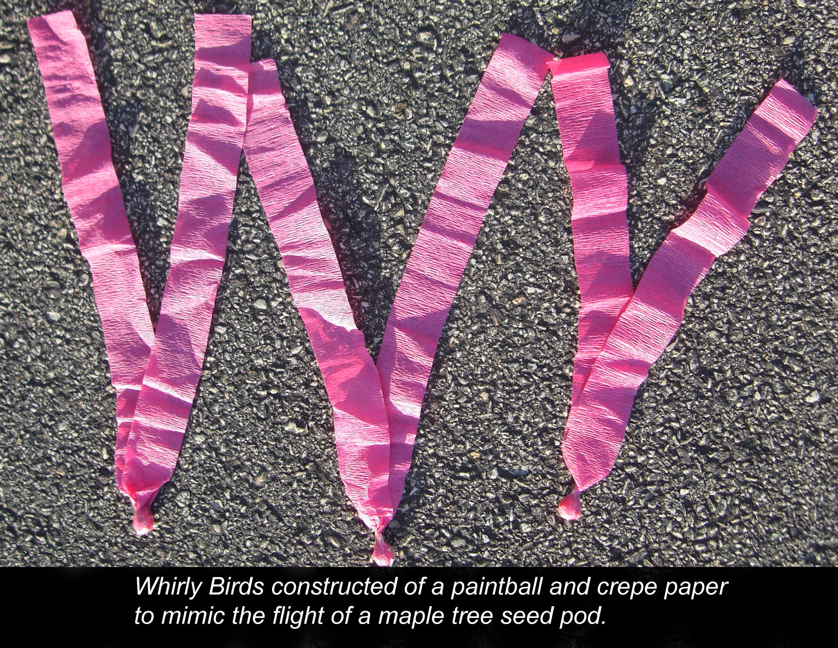

The Yough Cougar Rocketry team believes that Dorothy II’s design is highly aerodynamic and well balanced in proportion. It is believed that this design in Dorothy II will ensure a successful mission when the Range Safety Officer ignites her down in Huntsville, Alabama.

Preliminary analysis of the descent rate of the whirly bird will be determined using a grid sheet marked in feet and inches. A team member will then videotape a whirly bird as it is dropped to measure time and displacement.
The equation$y=\frac{1}{2}{\text{at}}^{2}$ and solving for the acceleration yielded $a=\frac{2y}{t^{2}}$. As the whirly bird dropped, its path could be seen on the video and the time was measured from the camera counter. This process is the same as is used in the Discovery Channel television show, Mythbusters.

A similar test to find the acceleration of the whirly bird was done by placing a whirly bird inside of the ¼ scale launch vehicle and a paintball without any crepe paper attached. The rocket was launched and videotaped. Once again, the camera timer was used to determine the time for the equations. From the video, the rocket reached apogee at 64 feet. The paintball can be heard impacting the football field. The difference in time was 2 seconds, yielding the 64-foot altitude at ejection using $y=\frac{1}{2}{\text{at}}^{2}$ and 32 feet per second squared as the acceleration of gravity. The whirly bird landed 10 seconds after ejection. Using $a=\frac{2y}{t^{2}}$ and the 64 feet as the vertical displacement, the acceleration of the whirly bird was found to be 1.28 feet per second squared. Due to the amount of streamer material for each whirly bird, it has been determined that the payload will reach terminal velocity almost immediately upon ejection. Therefore, the acceleration of the whirly bird can be considered constant throughout the flight path.

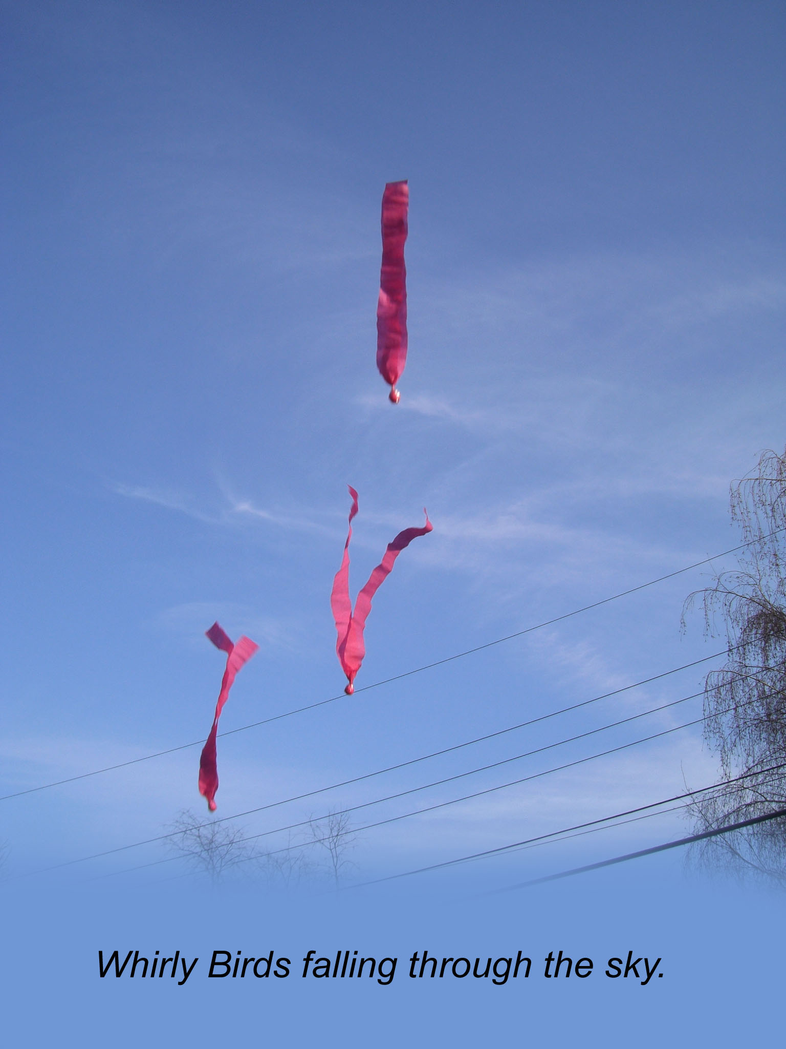

The integrity of the design is solid. During a test of the whirly bird being ejected from a rocket, it was noted that some of the crepe paper became scorched. It is believed that this may decrease the amount of drag on the whirly bird in flight, but to what extent, the team has been unable to measure since the amount of burnt crepe paper cannot be predicted. Therefore, it is the goal to provide a flame free environment for the whirly bird at all times to eliminate the scorching effect. While typing up the proposal, our team mentioned that there might be a possibility of electronic whirly birds in the payload section, but it is still undeterred whether or not we may have them. The electronic whirly birds consist of humidity, wind speed, temperature, barometric pressure and UV radiation sensors.

The whirly birds design causes it to open its wings when it is ejected out of the rocket therefore the wings of the whirly bird become untwined and spin like a helicopters blade causing it to flutter down to the ground safely.

Our workmanship in the creation of the whirly birds is to ensure that the whirly birds are cut to the same length, weigh the same, and consist of the same material. The electronic whirly birds will be made to the same specifications.

The equations for the component testing, functional testing, and static testing of the whirly birds are included in the test results. We gave not yet been able to obtain the electronic whirly birds, so we have been unable to run these three tests for the electronic whirly birds.

The team’s integration plan includes the following known details:

1. Provide Mr. Eric Haberman with the G10 material to be cut for fins and beveled
2. Begin construction of the electronics bay
3. Assemble bulkheads to create electronics bay
4. Install motor mount assemble provided by Mr. Eric Haberman
5. Install and epoxy fins upon return from Mr. Walters
6. Install hardware for attachment of shock cord and parachutes
7. Attach launch rail buttons
8. Mask off rail buttons and sand smooth the body tubes
9. Apply primer and paint launch vehicle
10. Apply decals

The Instrumentation used in Dorothy includes the G-Wiz LC 800 altimeter. For the specifications about this device, please refer to the document LC800 in PDF format.

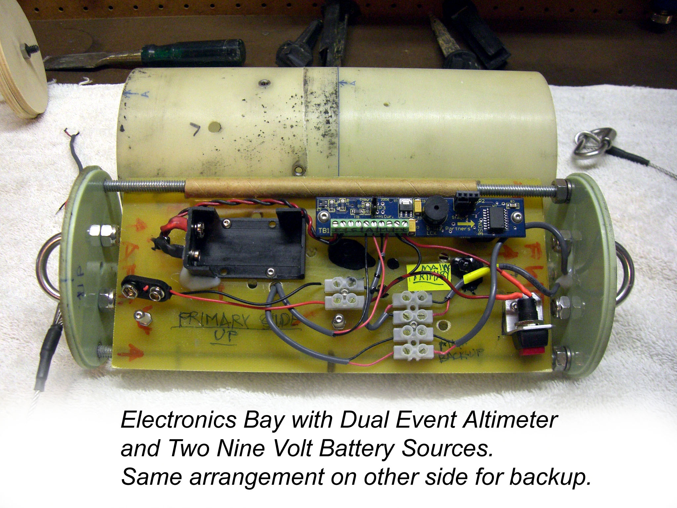
Josh “tins” the wires for installation into the electronics bay while Stephanie holds the solder in place. | 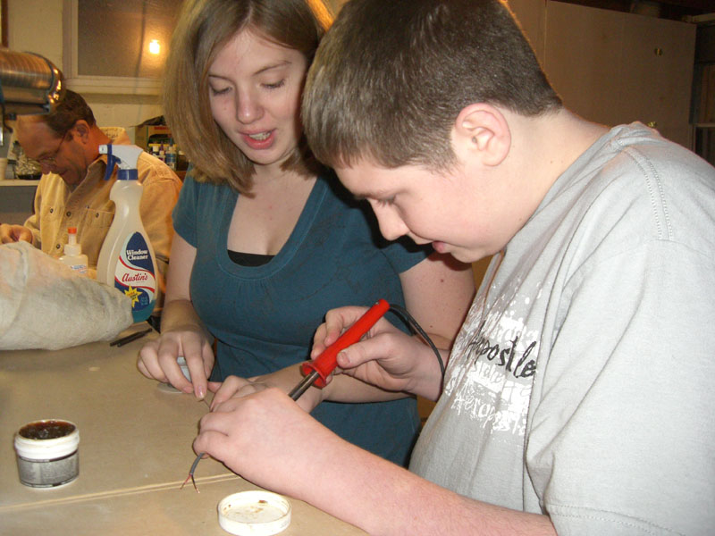

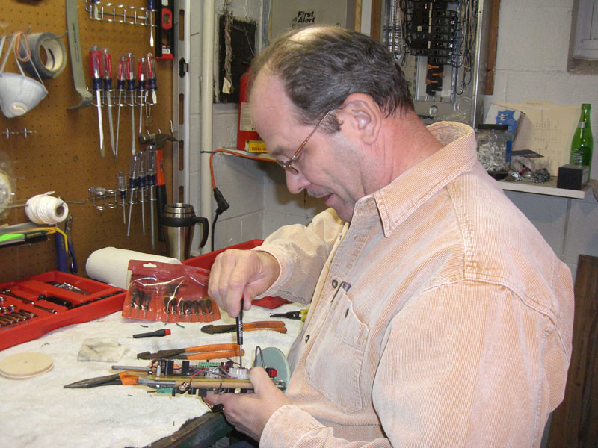 | TRIPOLI Pittsburgh member Ernie Walters verifies the assembly of the electronics bay assembled by members of the Yough Cougar Rocketry Team.

Safety concerns for the individual whirly birds are very low. Since they are a low mass object and have a high coefficient of drag, they descend at a very low rate. In the event that a person is not aware that a whirly bird is about to impact them, there will be no injury to that person. Failure concerns could result in the whirly bird falling at a high descent rate and therefore include possible injury. A failure would result if the crepe paper streamer did not unroll resulting in a lower drag coefficient and therefore a higher descent rate. With the electronic whirly birds, the decent will be the same, even though the electronic whirly birds will weigh more, simply because more crepe paper will be used. The weight of the electronic whirly birds may cause a minor injury to a person if they come in contact with its flight path.

Payload Concept Features and Definition

The whirly bird part of the scientific payload uses objects that are found in any consumer retail store. The whirly birds are made up of crepe paper and a paintball. Toto, the mechanical whirly bird, is composed of electronic sensors, electronic download devices, and computer hardware, which analyze data from the current weather conditions. Such hardware and assembly is not available in a “off the shelf” environment and must be purchased and assembled by a knowledgeable person.

The whirly bird is itself a very unique item that attempts to imitate a common natural phenomenon, the procreation of a maple tree. Many Americans can identify with the fluttering of a maple tree seedpod from their own backyard. Who in their right mind would consider placing a man made version of this natural occurrence? To answer that, you need not look any further than the entangled mind of our team leader, Miss Amy Bickerstaff. The significance of placing the whirly birds and Toto in a secure pouch enables our team to study the variations of wind patterns and current weather conditions given on the day of flight.

The suitable level for Amy Bickerstaff, Alicia Bowser, and Ashley Wiley are medium in the challenge level, because this is our third year in rocketry, and second year for a returning team in SLI. Josh Sarosinski and Stephanie Abbott are medium high in the challenge level, because they are second year rocketry members and only first year SLI members.

Science Value

The objective for the scientific payload is to determine if the predicted values for the dispersal of the whirly birds based on surface level winds is accurate with the actual dispersal after ejection from the launch vehicle.

The mission will be to recover and mark 70% of the pods for the splatter gram. The payload deployed with the main parachute will release 100 whirlybird pods. The payload data will then be analyzed using statistical methods to compare the theoretical data before flight and the actual results. During ejection of the drogue parachute, a large amount of colored chalk dust will be deployed from the parachute protector. This is to simulate the tiny spores of a biochemical agent and its far-reaching locations from such a low level explosion. No scientific data analysis will be done on this substance. It is solely for demonstration purposes, as the dust cloud will travel a distance outside of the launch area.

Another payload item that the Cougar Rocketry Team plans to include in Dorothy II will be an electronic whirly bird to mimic the ones that were used in the movie “Twister.” Obviously the movie made data pods seemed to gather a large amount of information very quickly. The data pods that the team plans to construct will include a barometric pressure sensor, temperature sensor, hygrometer sensor, and possibly a UV sensor. This is a new task for the team members as none of them have experience with electronic devices. The data pod will fall by means of a parachute along with the other whirly birds at a descent rate similar to or the same as the whirly birds. This way, data can be gathered from the displacement of the whirly birds and atmospheric data can be determined from the data pod. The mission success criteria for this payload is to recover all pods, download and view data from the electronic devices. Information from the data pods could then be used for further missions to conduct comparative analysis.

The Reason for the Whirly Bird Development

The original design of the whirly bird was to assist in the prediction of particle displacement of a biological substance or dust particles based on the surface level winds. Having knowledge of the ejection point in conjunction with the surface level winds, one should be able to determine the estimated landing point of particles by knowing their decent rate. Such development of this concept had been in place by governments around the world since World War I.

A large part of the development for the spread of biological and chemical weapons depended on scientists to explore the most effective means of delivery for these deadly chemicals and spores. The use of intercontinental ballistic missiles was to be the main delivery system. Project Dorothy wishes to recreate this delivery system and mimic the spores using the Whirly Birds.

Through the use of basic physics formulas, a prediction model will be formulated based on the weather conditions at the time of launch. A weather station utilizing an anemometer will yield an accurate value for the surface level winds around the launch site. By tracking the center of dispersion for the whirly birds via Global Position, the predicted and actual landing zones can be compared and contrasted. By reverse engineering the data, a possible prediction of the average wind speed from ejection point to ground level can be determined.

Summary of the Scientific Payloads Mission

The need for data in the weather conditions is obvious after reading how the proliferation of biochemical or spore related contamination could occur. Project Dorothy obviously has no intent on releasing harmful chemicals into the air; however, it does wish to provide a possible use in the battle against global terror by allowing governments to possibly design a similar rocket that can measure the needed data in the event of an attack. The team is very much aware that any biochemical agent released would be of much smaller size than the whirly birds or data ball (Toto) that are used to demonstrate the findings of the experiment. It is the goal of the Cougar Rocketry Team to show how even the slightest wind can easily disperse a semi-large object a great distance even when released from as low as 1000 feet.

Test and Measurement

Tests will be made by dropping both individual and groups of whirly birds from the bleachers at a height of 29 feet to get a short range prediction of the descent rates. Releasing whirly birds from model rockets will conduct larger scale tests on calm wind condition days. The altimeter on board will be used to determine the release point and multiple human timers will use stopwatches and visual methods to time the fall. Once again, basic physics equations will determine the decent rate. An average value will be determined from multiple launches.

Variables and Controls

Variables of the whirly birds include a possible mass difference, tail length, and entanglement upon ejection. In order to control these conditions, a scale could be used to weigh each whirly bird upon completion of assembly. The team does not believe that this is necessary as a possible small mass difference for an already low mass object could be significant. The tail length however seems to be more important to the flight characteristics. Therefore, trimming of tail lengths may be required once all 100 whirly birds are constructed. This construction will take place before arrival on site, thus eliminating the time element for completion. To minimize the entanglement factor, a light coating of baby powder and/or chalk will be applied to the packing materials during insertion into the airframe.

Relevance of expected data, accuracy / error analysis

Flight predictions for the whirly birds are based on the velocity of the winds at approximately 800 feet when the main parachute and payload will be deployed. Any wind will cause the whirly bird to fly in a trajectory that is not totally vertical, therefore including a horizontal vector. Establishing this vector using physics equations will allow for comparison to the surface level winds. It is expected that the whirly birds will travel farther than the prediction based on the surface level wind speeds. This hypothesis is based on real life occurrences experiences during the Team America Rocketry Challenge finals held in Manassas, Virginia. The team noticed that the weather balloon station set up on site seemed to always indicate that the wind speed was progressively higher at each successive altitude marker. To complete the mission, the team is attempting to derive a linear equation that can predict the wind speed at certain altitudes in order to conclude where biological spores could land if released from known altitudes. Preliminary study was to release whirly birds at apogee and 800 feet. Having two data gathering points would have allowed for better error analysis to improve the accuracy of the prediction equation. However, having only one data set from the April, 2008 launch will limit the accuracy values. Therefore, the Cougar Rocketry Team is going to attempt to compare the data with the April launch to the proposed test flight to be held in February or March of 2008. Low altitude tests with the 66% scale rocket will also be conducted in order to establish a baseline for ejections at 800 feet if the scale version is capable of attaining this altitude.

The data ball, Toto will collect atmospheric data at a proposed rate of one unit per second. This data rate is established by the manufacture of the devices. Currently, this data rate is believed to be too slow establish useful information, however, the team plans to keep this payload in place in order to learn more about electronic data gathering.

Experiment Process Procedures

A series of events must occur in order to maximize the potential for success of the payload.

- All Whirly Birds are to be the same size and approximate mass
- Whirly Birds must be free to release from the airframe without restriction
- Ejection charge must be of sufficient strength to eject entire payload
- Whirly Birds must not become entangled in recovery systems
- Whirly Birds must be physically located for GPS data acquisition
- 70% of the Whirly Birds must be located for reliable results
- Whirly Birds must not be damaged at any time during the flight or descent to Earth
- Data must exhibit a positive or negative mathematical correlation to formulate equation
- Electronic Data Ball “Toto” must sustain the excessive launch forces
- Parachutes must not be damaged upon ejection (burnt or torn)
- Toto must have the same descent rate as the Whirly Birds
- Toto must land in a location capable of retrieval
- Electronic data storage devices must operate correctly to retrieve vital data from flight
- Computer analysis of data should agree with the Whirly Bird data
- An attempt of transmitting real time data during flight is in process

Safety and Environment ( Payload )

Stephanie Abbott is the Safety Officer for the Yough Cougar Rocketry Team.

Failure of the following launch vehicle items must be addressed to ensure proper ejection and recovery of the payload incased in Dorothy II.

Fins: In the event that a rocket fin would fall off, then the rocket could possibly fly uncontrollably in any direction causing the payload to be damaged or inaccurately released at an altitude not suitable for data analysis. To prevent such an event, ensure that the fins are properly epoxied into the airframe and that the fin material is of appropriate strength to withstand the forces encountered.

Motor and Parachute- In the event that the motor doesn’t fire properly,
- If the motor does not have enough thrust then the rocket might not reach its potential apogee, thus causing the chalk demonstration to yield unsatisfactory results.
- Rocket could yaw excessively under low or partial thrust causing the payload to be damaged or be destroyed during a high-speed ground impact.
- If the parachute deployment is altered by motor malfunction, the parachute may not deploy; therefore resulting in the payload failing to deploy from the airframe.

Personal Hazards and Avoidance Procedures

Cuts from sharp instruments, scissors: don’t run with scissors
Burns from soldering iron: place soldering iron in holder when not in use
Poison risk from paintballs: do not ingest or apply pressure to paintball causing rupture
Static discharge cautions: properly ground oneself before handling electronic devices in data ball
Other First Aid: Located first aid kit in a location convenient to all personnel in the working environment in case injury occurs

Additional personal hazards that can occur include,

Before the rocket launches
- Failure to arm the ejection charge systems resulting in payload not being deployed
- Accidental launch before spectators are at a safe distance causing payload to land in the spectator area
- Personnel could drop or damage rocket causing system failures
To prevent such things from happening
- Have more than one person overlooking preparation of launching and ejection systems
- Make sure that everyone is in the safety zone before launch of the rocket
- All personnel need to be aware of the surroundings to watch for falling payload items
- Store rocket in a secure location to prevent damage to the payload
During the rocket launch
1.) Personnel could lose visual contact with the launch vehicle and payload
2.) Rocket could have a malfunction resulting in payload impacting nearby equipment or
personnel

To prevent such things from happening
- Have more than one person watching the payload and pin-pointing a location for landing
- Watch the payload at all times and if payload approaches, seek cover
- Monitor the location of all payload pieces in order to recover and pick up to prevent environmental harm

Environmental Concerns

If the payload is not recovered
- Animals may attempt to ingest crepe paper or paintballs, therefore becoming sick
- Battery from Toto could leak into the Earth and cause contamination of the nearby soil and/or groundwater supply
- Electronic boards in Toto could deteriorate if left in an outdoor environment for a prolonged time period, thus resulting in possible contamination of the nearby soil and/or groundwater supply
- Plastic encasement for Toto could separate and leave behind sharp plastic material capable of injuring an individual or animal if stepped upon

Things to do to prevent such things from happening

Many of the materials used in the construction of Dorothy II are made of biodegradable substances and designated personnel are to monitor any pieces that may detach from the airframe.

V). Activity Plan

Budget Plan

Due to substantial changes in the budget for NASA, the Yough Cougar Rocketry Team has been asked to pay for the expenses incurred for the culminating activity for the NASA SLI 2008 to be held from April 23 – 28, 2008. The team anticipated the $1250 grant monies would be used to purchase the Quest Starhawk rocketry kits to be used in the outreach. Currently, that money is being reserved to assist with the transportation costs and lodging for the team.

Below is the proposed budget as outlined in the original proposal.

Proposed Budget

The proposed budget for “The Whirly Bird Experience” will be an ongoing and updated element of the project. As the design evolves, new materials will need to be added and some removed.

Part Description | Manufacture or Supplier | Cost
Nose Cone | Performance Rocketry | $ 30.00 each (2)
Body Tubes | Performance Rocketry | $ 18.00 per foot (16)
Tube Coupler | Performance Rocketry | $ 64.00
MadDog Dual Deploy Kit | Performance Rocketry | $ 159.00
Payload ( paintballs ) | Wal-Mart | $ 30.00 per 1000
Parachute ( drogue ) | SkyAngle Cert – 3 | $26.13
3/16” G10 Fins | Performance Rocketry | $30 per sheet
Parachute ( main 60” ) | SkyAngle Cert – 3 | $ 132.05
Insta-Cure CA Glue | BSI Adhesives | $ 3.99 each (4)
Slow Set Epoxy | BSI Adhesives | $ 7.99 each (2)
Steamer Material | Wal-Mart | $ 1.99 per roll (3)
Sandpaper Assortment | Wal-Mart | $ 6.99
Space Cad Software | Rocket Motion | $ 54.95
RockSIM Software | Apogee Components | $ 99.99
Altimeter Alt15K/WD | Perfectflite | $ 69.95
LCX Dual Event Alt. | G-Wiz | $ 99.95 (2)
Rail Guides | Giant Leap Rocketry | $ 3.29 / pair
JB Weld | Wal-Mart | $ 5.65
Krylon Paints | Wal-Mart | $ 5.97 per can (3)
PC-7 epoxy | Lowe’s | $7.97
Starhawk Rocket for Outreach | Quest Education | $95.00 per 25 rockets (8)
Motors for Outreach | Quest Education | $39.00 per 25 motors (8)
Estimated Total Cost of Launch Vehicle and Payload |  | $ 2365.69

The ¼ or 66% scale model will be built primarily with Estes products. Some items are already available to the team with leftover parts from TARC. Below is an estimate of costs for the scale model.

Part Description | Manufacture or Supplier | Cost
Nose Cone BT-80 | Estes | $ 7.99
BT – 80 Body Tubes | Estes | $ 13.79
BT – 80 tube couplers | Estes | $ 8.99
Parachutes | Top Flite Recovery LLC | $ 12.99
Insta-Cure CA Glue | BSI Adhesives | $ 3.99 each
Motor ( Aerotech F – 20 ) | Red Arrow Hobbies | $ 25.95 each – need 3
Basswood Fin Material | Midwest ( Tower Hobbies ) | $ 2.85 per sheet – need 3
Estimated Total Cost of Scale Launch Vehicle and Payload |  | $ 108.20

The total estimated cost of the materials for both launch vehicles is projected to be $ 2473.89. This value would be under ideal circumstances. Since we are constructing such a large-scale rocket and items may change, this budget is only an estimate as some of the material purchased for the 2007 SLI were able to be reused.

Funding Sources

Upon acceptance of the proposal, the Yough Rocketry Team will use the funds provided by NASA through the SLI grant as well as outside resources. The owner of BSI Adhesives, maker of the Quik – Set and Slow – Cure epoxy has already provided products from the company inventory. Westinghouse has already provided a $2000 gift after the 2006 – 2007 NASA SLI was completed in hopes that the funds would be used to reconstruct Dorothy for the 2007 – 2008 SLI. This was due to the fact that Mr. Eric Haberman, an employee of Westinghouse, fabricated the fiberglass for the original Dorothy. Mr. Haberman’s name, as well as Westinghouse, was mentioned in several local newspapers, thus showing the commitment to education from the Westinghouse Corporation. The YHS rocketry team will be applying for the Toyota Tapestry grant also. However, this grant will not be selected until January of 2008. Local businesses have allowed the team to place fundraising materials (lollipops, candy bars, and trail mix snacks) in their establishments to increase the funding availability. These items provide an average of 90% profit on each item sold. Individuals are also selling the fundraising items during school hours in room 100, the main office, and in the hallways. Last year, these sales accounted for an income of approximately $1400, which supplemented the teams meals and souvenirs during the Huntsville trip. Ashley Wiley’s mother, Donna Montecupo, also solicited funds from local businesses in excess of $300. With the continued success of the Cougar Rocketry Team, more business establishments are becoming more willing to fund the team’s endeavors. Some of these businesses have been increasing their donations each year as the Cougar Rocketry Team continues to grow. State Representative Ted Harhai and Senator Bob Regola also plan to ask the Commonwealth of Pennsylvania for a grant designed specifically for rocketry based projects upon acceptance into the 2007 – 2008 SLI program.

A breakdown of additional expenses is provided below.

Item Required | Cost each | Total Cost | Paid / Unpaid
Airline Tickets | $ 270 | $ 2,700 | Unpaid – $ 400 Deposit sent
Lodging | $ 75 per room per night + tax | $ 2125 | Unpaid
Meals | $ 40 per person per day | $ 2000 | Unpaid
Rental Van | $ 600 per week | $ 600 | Unpaid
Total Cost |  | $ 7425

At the time of the writing of this document, the computer sales have yielded a total income of $3780. Approximately $1500 has been raised through candy sales thus far. Other organizations have also been selling similar items, thus cutting into the sales volume once experienced by the teams’ sales. The Pittsburgh Penguins, Steelers, and Pirates have been donated some items for a Chinese Auction to be held in March or April. Seven Springs Ski Resort also donated ski passes and tubing tickets. Some restaurants and stores are also donating gift cards. The team hopes to earn approximately $2000 from this event.

Timeline

The Cougar Rocketry Team plans to use the following timeline for implementation of the mission goals for Project Dorothy.

September 2007;
- 20th – Have the proposal completed in rough draft form
- 24th – Have the proposal in completed form
- 27th – Mail proposal, no later than, September 29th
- 29th – Send e-mail as backup copy

All September Mission Goals Complete

October 2007:
- 1st – NASA SLI Proposal received at Marshall Space Flight Center, Huntsville, AL
- 22nd – Await notification of selection
- 22nd – Submit Payment Information Forms
- 23rd – Arrange SLI Team Teleconference/ Video Teleconference
- 25th – Contact News agencies for coverage on the acceptance into the SLI program
- 26th – No School, Teacher in-service day
- 29th – Begin writing the Preliminary Design Review (PDR)
- 30th – Reconstruct the quarter scale rocket
- 30th – Update Website with current information and team data
- 30th – NASA media announces new 2007 – 2008 SLI Teams
- 31st – Halloween

All October Mission Goals Complete

November 2007
- 5th – Web Presence Established (complete)
- 7th – Launch of ¼ scale rocket (delayed due to poor weather conditions)
- 12th – No School, Teacher in-service day (complete)
- 13th – Launch of whirly birds to monitor flight characteristics (complete)
- 16th – Have PDR rough draft completed (complete)
- 22nd – Thanksgiving Day (we ate too much)
- 23rd – No School, Holiday Break (shopping was fun)
- 26th – No School, First Day of Deer Season (no animals were harmed by our team)
- 28th – Have PDR final copy completed
- 28th – Submit PDR to Julie Clift and post on Website

All November Mission Goals Completed

December 2007:
- 3rd – Begin construction of full scale launch vehicle – Dorothy II
- 21st – Construction of Dorothy II complete in unpainted form
- 21st – Last Day of Classes before Christmas Break
- 25th – Christmas Day
- 27th – Team meeting to begin paint preparation
- 31st – New Year’s Eve

Construction of Dorothy II is behind schedule

January 2008:
- 1st – New Year’s Day
- 2nd – Classes resume
- 11th – Begin to finalize the Critical Design Review (CDR) and PowerPoint Slides
- 18th – Have CDR Presentation Slides and CDR report completed
- 21st – No School, Teacher in-service day (work day for team on CDR)
- 22nd – Critical Design Review submitted to Julie Clift and posted on Website
- 28th – Critical Design Review Video Teleconference
- 28th – Submit Second Invoice

February 2008:
- 2nd – Chinese Auction and Outreach at Sam’s Club Greensburg
- 4th – Begin the Flight Readiness Review (FRR) Report
- 14th – Valentine’s Day
- 18th – No School, teacher in-service day
- 19th – Rough draft of FRR complete
- 20th – Being the PowerPoint slides for the FRR
- 23rd – Possible test flight of Dorothy II at the Tripoli launch site

March 2008:
- 10th – No School, teacher in-service day
- 14th – Have the FRR in completed form, both report and PowerPoint
- 17th – St. Patrick’s Day
- 19th – Lama’s Club Outreach
- 20th – No School, Easter Break begins
- 23rd – Easter Day
- 24th – Flight Readiness Review submitted to Julie Clift and posted on Website
- 25th – Last day of Easter Break
- 31st – Flight Readiness Review Video Teleconference
- 31st – Submit the Flight Readiness Review invoice

April 2008:
- 2nd – Paint completed on Dorothy II
- 7th – Finalized test firings of ejection charge systems
- 15th – Begin the shipping procedures for the full scale rocket
- 21st – Dorothy II arrives in Huntsville via FedEX ground
- 23rd – Team travels to Huntsville, AL
- 24th – Rocket Fair
- 25th – Yough High School Prom
- 26th – Launch Day
- 27th – Travel back to Pennsylvania

May 2008:
- 5th – Post – Launch Assessment Review (PLAR) in rough form
- 17th – Team America Rocketry Challenge
- 20th – No School, Snow makeup day
- 23rd – Post – Launch Assessment Review (PLAR) due
- 23rd – Submit final invoice for 2007 – 2008 SLI program
- 26th – Memorial Day, No School

Outreach – Business Involvement and Public Exposure

The YHS Rocketry Team will solicit donations from local businesses in exchange for advertising on the SLI web site. High power rocketry skills will be acquired from the Pittsburgh Space Command rocketry club and Pittsburgh TRIPOLI chapter. At least one member of the YHS Team will attend launches in the local area when possible. Supplies will be sourced from various Internet locations and / or local NAR members. The local UPS and FedEX shipping warehouse will be contacted to inquire about low cost or free shipping of the ground support and launch vehicle as necessary. WPXI television has already featured the YHS Rocketry Team in an earlier segment for TARC and as time permits for additional follow-up, will continue to monitor the progress of the SLI objective. KDKA television has also shown an interest in the NASA SLI program; however, breaking news events have prevented news crews from visiting the Yough School District when the students were available. The Greensburg Tribune-Review ran a feature article about the Cougar Rocketry Team and their accomplishments in April of 2007. This article provided the much needed exposure to the program. Editors at the newspaper informed the team that continued coverage would be available.

Westinghouse Corporation’s Plasma Research Center located in Madison, Pennsylvania provided the Cougar Rocketry Team with a $2000 cash grant at the completion of the 2007 SLI after learning of the crash landing sustained by Dorothy. Westinghouse has been an increasing presence in the community with regard to engineering projects, which are being completed in the Yough School District. It was the intent of the Westinghouse Corporation to assist the team in successfully completing the mission first set forth by Dorothy I in 2007. Mr. Eric Haberman, an employee of Westinghouse was vital in the construction role and fiberglass cutting for the original Dorothy. His presence in the project was held in high regard within the Westinghouse community.

The team has also been refurbishing computers that were once used in the labs of the schools to provide a service to the community. These used computers are being sold to students and parents who are unable to afford new computer systems. Some benefits of these sales are that old computers are not being thrown into the trash and damaging the environment as well as spreading the Cougar Rocketry Team name for beneficially serving the Yough community. All of the computers were donated to the team by the Yough School District, therefore allowing all proceeds to go directly to the cost of the Huntsville trip in April.

A Chinese Auction will be held in conjunction with the new outreach program. Items donated will be drawn for from tickets sold for $1, 3 for $2, 5 for $4, 20 for $10. Minor costs are associated with this event.

Outreach – Younger Student Involvement and Program being sustained

The student outreach has been highly modified due to the funding issues and restrictions placed on the team by the Yough School District. The team is unable to conduct an outreach in the middle school science classes as once anticipated. However, the team is still attempting to attend the science fair with some type of display. A new program has been devised to consist of distribution of the Quest Starhawk rocket during the public sales events for the Chinese Auction. Approximately 100 Starhawk rocket kits are going to be handed out to children and young teens at the Greensburg Sam’s Club, West Newton Giant Eagle, and Herminie Bill’s Dandy Dollar store. Patrons will be given a pamphlet including the Cougar Rocketry Team’s website to learn details of a rocket fair to be held at the high school in late March or April. Those who received and built their Starhawk will be given the opportunity to fly their rocket on a Quest A6-3 motor. The winners of the Chinese Auction will also be determined that day.

A second outreach program will hopefully be held at the middle school’s science fair. The reason for this outreach will be that many of the parents will be attending the event. More of the community will be made aware of the activities that the Cougar Rocketry Team is involved with and the team wishes to inspire the parents to influence their children to get involved into model rocketry. The sport of model rocketry provides an excellent opportunity for parents to participate in an activity that is beneficial to their children. Cooperative activities provide a bridge of communication and help to provide a bond that can lead to greater success in school and the family. The team will set up a table at the science fair with information about rocketry and provide a demonstration if the weather permits.

Example of the rocket kit being built by the students for outreach | 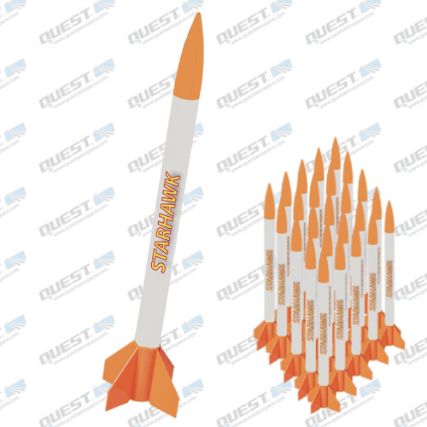

VI). Conclusion

The Yough Cougar Rocketry Team is very pleased to have been selected for the 2007 – 2008 Student Launch Initiative as a returning team. Having completed the criteria during the 2006 – 2007 SLI, the group believes that they have achieved a higher level of understanding of the design process and implementation of a schedule plan. The lessons learned last year after the disastrous fall of Dorothy has allowed the team to make modifications to the new design in order to possibly eliminate the failure of the recovery systems. Even though Dorothy II is the same with regard to physical dimensions, the internal workings are totally new. Dorothy II will even have a new look, sporting a new Wizard of Oz theme. One of the benefits of the SLI program that the group is looking forward to is reacquainting with old friends from the previous year and meeting new ones this year. Another goal the team wishes to achieve is to broaden the public eye as to the program and the accomplishments that are being completed within the Yough School District as the other sports overshadow the importance of the SLI program and sport rocketry. From all of us, to all of you, thank you for another wonderful opportunity.

