Yough High School
Cougar Rocketry Team

The Whirly Bird Experience
a.k.a. Dorothy Flies Again

Table of Contents

Vehicle Criteria 1
Safety and Failure Analysis 4
RockSim drawing of Dorothy 6
Overall Design of Dorothy 7
General Arrangement of Dorothy 8
General Assembly of Dorothy 9
Altitude Prediction from RockSim 10
Thrust Curve from RockSim 11
Vertical Acceleration from RockSim 12
Velocity Prediction from RockSim 13
Review the Design at System Level 14
Recovery Subsystems 15
Timeline and Objectives 17
Scale Rocket Tests 19
Payload Integration 20
Procedural Plan for team members 21
General Launch Operation Procedures (Tripoli) 24
Safety and Environment (Vehicle Criteria) 27
Payload Criteria 29
Experiment Concept 31
Science Value 32
Safety and Environment (Payload Criteria) 39
Launch Operation Procedures (Checklists) 40
Outreach Program 45

Yough High School Rocketry Team
919 Lowber Road
Herminie, PA 15637
724 – 446 – 5520 ext. 2015
http://www.infinitefx.com/nasasli

Critical Design Review - Vehicle and Payload Experiment Criteria

I. Vehicle Criteria

It is the mission of the Yough High School Rocketry Team to design, build, test and launch a high powered rocket attaining an altitude of 5280 feet (one mile), and record data from designated release points of whirly birds like those of maple tree seed pods in order to study wind variation at specific altitudes for further study of weather patterns. Mission success will be determined by the retrieval of 75% of the whirly bird pods deployed at the targeted altitudes and safe return of the launch vehicle.

The project began on August 25, 2006 with a brainstorming meeting to discuss possible payload ideas. The written proposal for SLI acceptance began on August 31, 2006 and continued until completed prior to October 2, 2006. Manufacturing of a ¼ scale launch vehicle began October 16, 2006 and concluded by December 8, 2006. The Preliminary Design Review started on October 23, 2006, and gave a teleconference on approximately November 27, 2006. This date was on a day off from classes so other arrangements have been made. A test launch of the ¼ scale model was tested on December 20, 2006. A dedicated web site to the discussion of the team’s progress and development is online before the date of October 27, 2006. The Critical Design Review began November 10, 2006 and concluded on January 22, 2007. The Flight Readiness Review began on August 25, 2006 and will last until March 26, 2007. The team will travel to Huntsville, Alabama April 25 through 29, 2007. The data and final report are to be submitted no later than May 18, 2007; however, this is the same dates for the TARC finals in Virginia. This event may delay the posting of the report to the web site.

G – 10 Fiberglass as chosen for its durability, strength and recommendations by experienced high power rocket builders. The bulkheads and centering rings are also made from G – 10 material. G – 12 was used for the motor mount tube with an aluminum retaining ring. Stainless steel hardware was used for the all thread, nuts, cables, and quick release rings for its resistance to corrosion and high tensile strength.

The design is consisting from nose to tail of: Nose Cone, Main Parachute, Whirly Bird deployment bag with Whirly Birds (deployment B), Shock Cord, Deployment charge, Bulkhead, Coupler, Electronic bay with altimeters, Drogue Parachute, Whirly Bird deployment bag with Whirly Birds (Deployment A), Shock Cord, Ejection Charge, Bulk Head, Engine Bay, Engine, Engine Stops, all which is incased in a four inch fiberglass airframe, with three quadrilateral fins.

For the main frame, the team used a four-inch fiberglass tube. The group chose the four-inch fiberglass tube because of its functional ability for our project and its structural content. The team also used a four-inch bulk plate to match the four-inch fiberglass tube. For all the fastening hardware we used stainless steel materials. By choosing to use the stainless steel materials, the likelihood of fractures will be reduced. Using the ball barring swivel clip, it enabled us to fasten movable objects securely and safely. The fins are a quadrilateral rearward sweeping form. The fins also have a tab that slides into the main airframe to ensure stability. For the fins the team chose to use a .1875-inch (3/16 inch) G-10 fiberglass for fin material. Choosing the G-10 has benefits including having a high tensile and shatter/ break point. To ensure proper assembly, our local high power rocket mentor (Ernie Walters) will be overseeing the complete building process. Having his supervision of the building process enables the team to construct and design the rocket properly.

The subsystems required for a successful mission is the drogue parachute, both payloads, both ejection charges, main parachute, altimeter, engine bay, engine, engine retainer, airframe, and fins. Each subsystem must perform effectively, such as the Whirly bird deployment bags properly deploying the Whirly Birds, the ejection charges properly ejecting, the engine properly staying in place and burning effectively, and the parachutes slowing the rocket down enough for a safe recovery. To verify that all subsystems work in unison and effectively, each system will be bench tested under controlled conditions.

The risks and plans for reducing risks through analysis and/or testing of each subsystem will be as follows; ejection charges - bench test, parachute – analyze air resistance versus weight and scale model test, Whirly Bird deployment – test and analyze, engine – analyze and possibly test if budget and sufficient location is available. Each subsystem will be tested and inspected before launching, before shipping, after shipping, and during the design phase.

In order for the rocket design to work effectively, our local high power rocketry mentor (Ernie Walters) helped our team to finalize our design, and reduce all miscalculations. The design is completed and construction is on going.
The launch vehicle assembly was constructed under the supervision of Mr. Ernie Walters and Mr. Eric Haberman. Eric Haberman has built many rocket assemblies for TRIPOLI members for Level I to III certification. Mr. Haberman is a Nuclear Engineer with the Westinghouse Company. He has access to many pieces of equipment to cut fiberglass and create jigs for alignment as were used in the construction of Dorothy. Alignment of the fins was accomplished by slotting the airframe in Mr. Haberman’s shop with perfect 120° spacing of the fins. Connection points for the attachments were all selected from previous rocket construction experience by Mr. Walters and Mr. Haberman. Such connections were then reinforced with either more substantial materials than needed or with redundant systems. Attachment of the fins was done by notching the fins to interlock with the centering rings of the motor mount in three locations. Loctite Hysol epoxy was used to attach the motor mount, fins, and all thread into the nose cone.

Most tube couplers are held in place using four through the wall screws. Dorothy uses six 8-32 button head screws attaching to nuts epoxied to the interior of the coupler. The cables connecting the coupler to the main body of the launch vehicle run parallel to the motor mount and are attached to the centering rings. Epoxy was applied to both sides of the centering rings to strengthen to bond between the airframe and the motor mount assembly. All loads should be displaced into the motor mount assembly through the cables. A snap ring holds the motor securely in place. This design was engineered by Eric Haberman and is used by TRIPOLI members in the Pittsburgh area frequently.

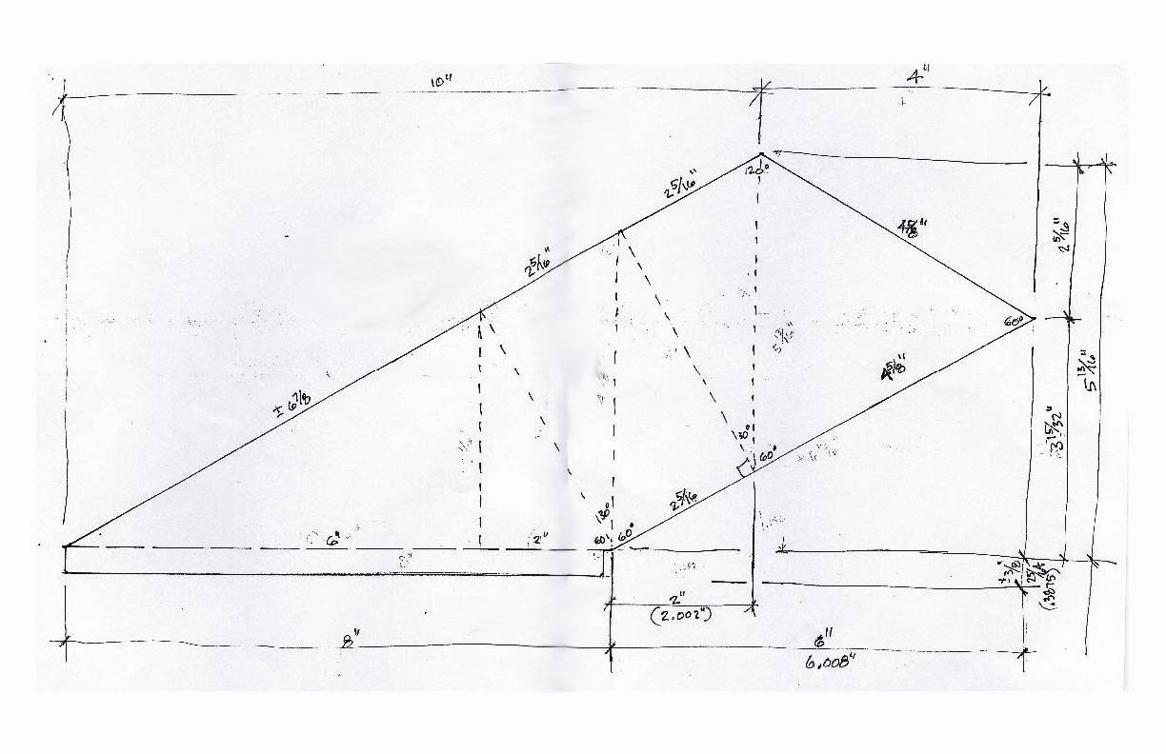
The shape of the fins is designed have little air resistance while also maximizing the stability by creating great amounts of surface area in the fins.
Experienced model rocket builders such as Mr. Ernie Walters and Mr. Eric Haberman have made it possible for the design of Dorothy to be closely examined. Because of this, the integrity of the rocket is sound both in structure and design as well as attractiveness resulting in a professional quality assembly. With the assistance of the Art department led by Mr. Bob Weaver and Pittsburgh Tripoli member Dave Rose, a highly detailed graphics decal will be made and applied to a once plain Dorothy resulting in a stellar appearance.

Safety and Failure Analysis

The following table outlines possible failure modes and the undesired outcomes. Restrictive mitigations are outlined to prevent the failures as noted. Further development of this critical area will be completed as new issues arise during construction and or the testing phase.

Failure Modes | Causes | Effects | Restrictive Mitigations
Dismount of Fins | Improper attachment of fin to airframe | Fins detach and fall/flutter to the Earth uncontrollably | Proper attachment of fins to the airframe
Engine Misfire | Faulty Motor  Faulty Ignition  Faulty Igniters  Faulty Preparation | The rocket will not leave the launch pad.  Engine will not burn entirely | Proper Inspection  Proper Inspection
Engine Dismount | Improper installation of motor retaining system | Engine could slide out of Airframe and free fall to the ground  Rocket may not reach desired altitude  Engine propel itself toward the ground and possibly spectators  KATO | Proper installation of engine retaining system and Inspection
Engine Detonation | Defective engine from factory | Motor self destructs, and Rocket destruction  KATO | Inspect motor grain pellets if at all possible
Premature Ignition | Accidental ignition from igniter or static electric sparks | Rocket take-off before planned, also possibly before ready for launch and all necessary safety and onboard electronics are working | Proper safety switches  Static Free Environment
Parachute not deploying | Deployment charge not igniting | Dangerous Landing | Bench test and Redundant System
Electronics bay malfunction | Loss of power to electronics  Faulty electronics | Ejection not occurring | Bench test and Redundant System
Parachute Detachment | Malfunction of shock cords, cables, etc; and attachment | Parachute and rocket separation not occurring and possibly a dangerous landing situation | Inspect all parts for damage
Shear pins not shearing | Not enough pressure applied from ejection | Parachute not deploying and possible crash landing | Bench test and analyze

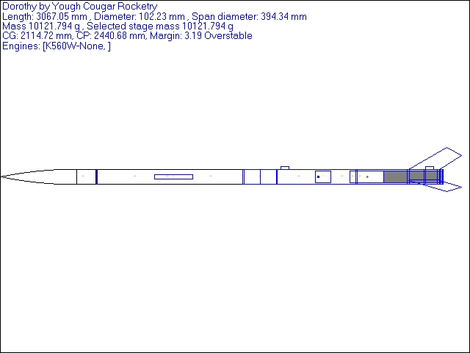

RockSim drawing of Dorothy
Overall Design of Dorothy
Created by Eric Haberman

General Arrangement of Dorothy
Created by Eric Haberman

General Assembly of Dorothy
Created by Eric Haberman

Altitude Prediction from RockSim

The Animal Motor Works K560 should provide amble thrust to reach the altitude goal 5280 feet. A prediction from RockSim shows an altitude of 5383 feet as seen below.

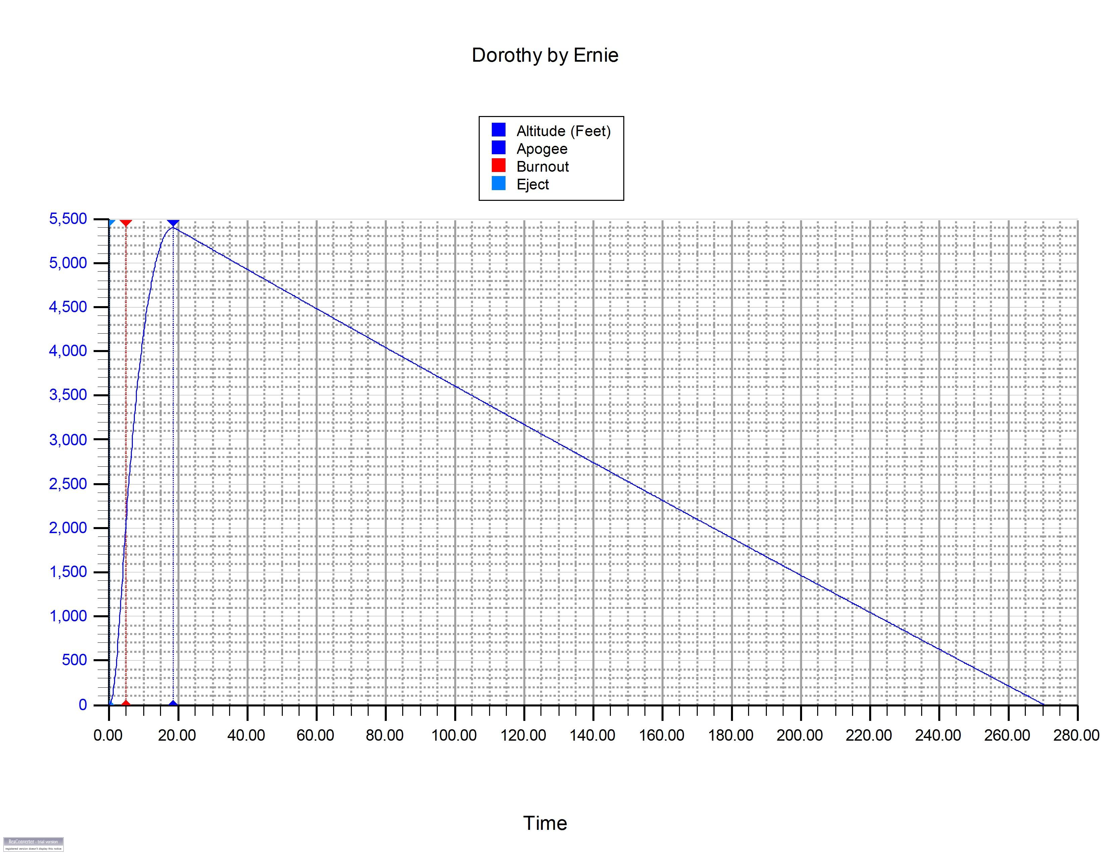

The thrust of the motor on the rocket results are included below. The peak thrust experienced on the launch vehicle is predicted to be approximately 800 Newtons.

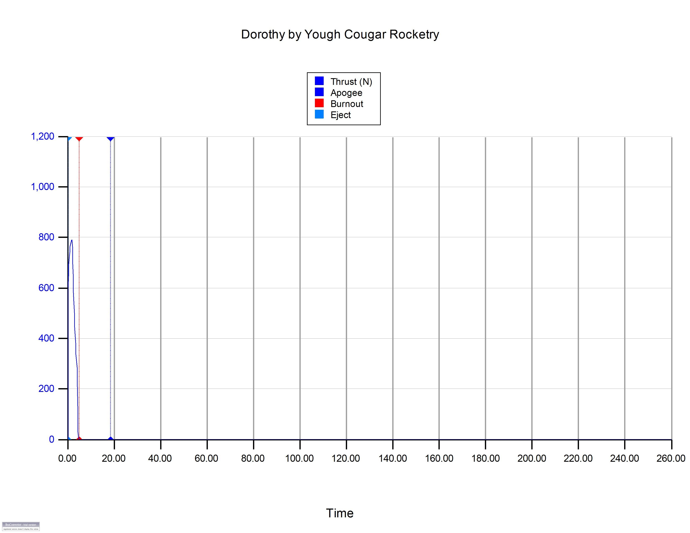

The nearly 800 Newtons of thrust will yield a great amount of acceleration. RockSim has predicted this value to be approximately 230 feet per second squared. This value indicates that the launch vehicle and its payload will experience about seven ( 7 ) times the force of gravity.

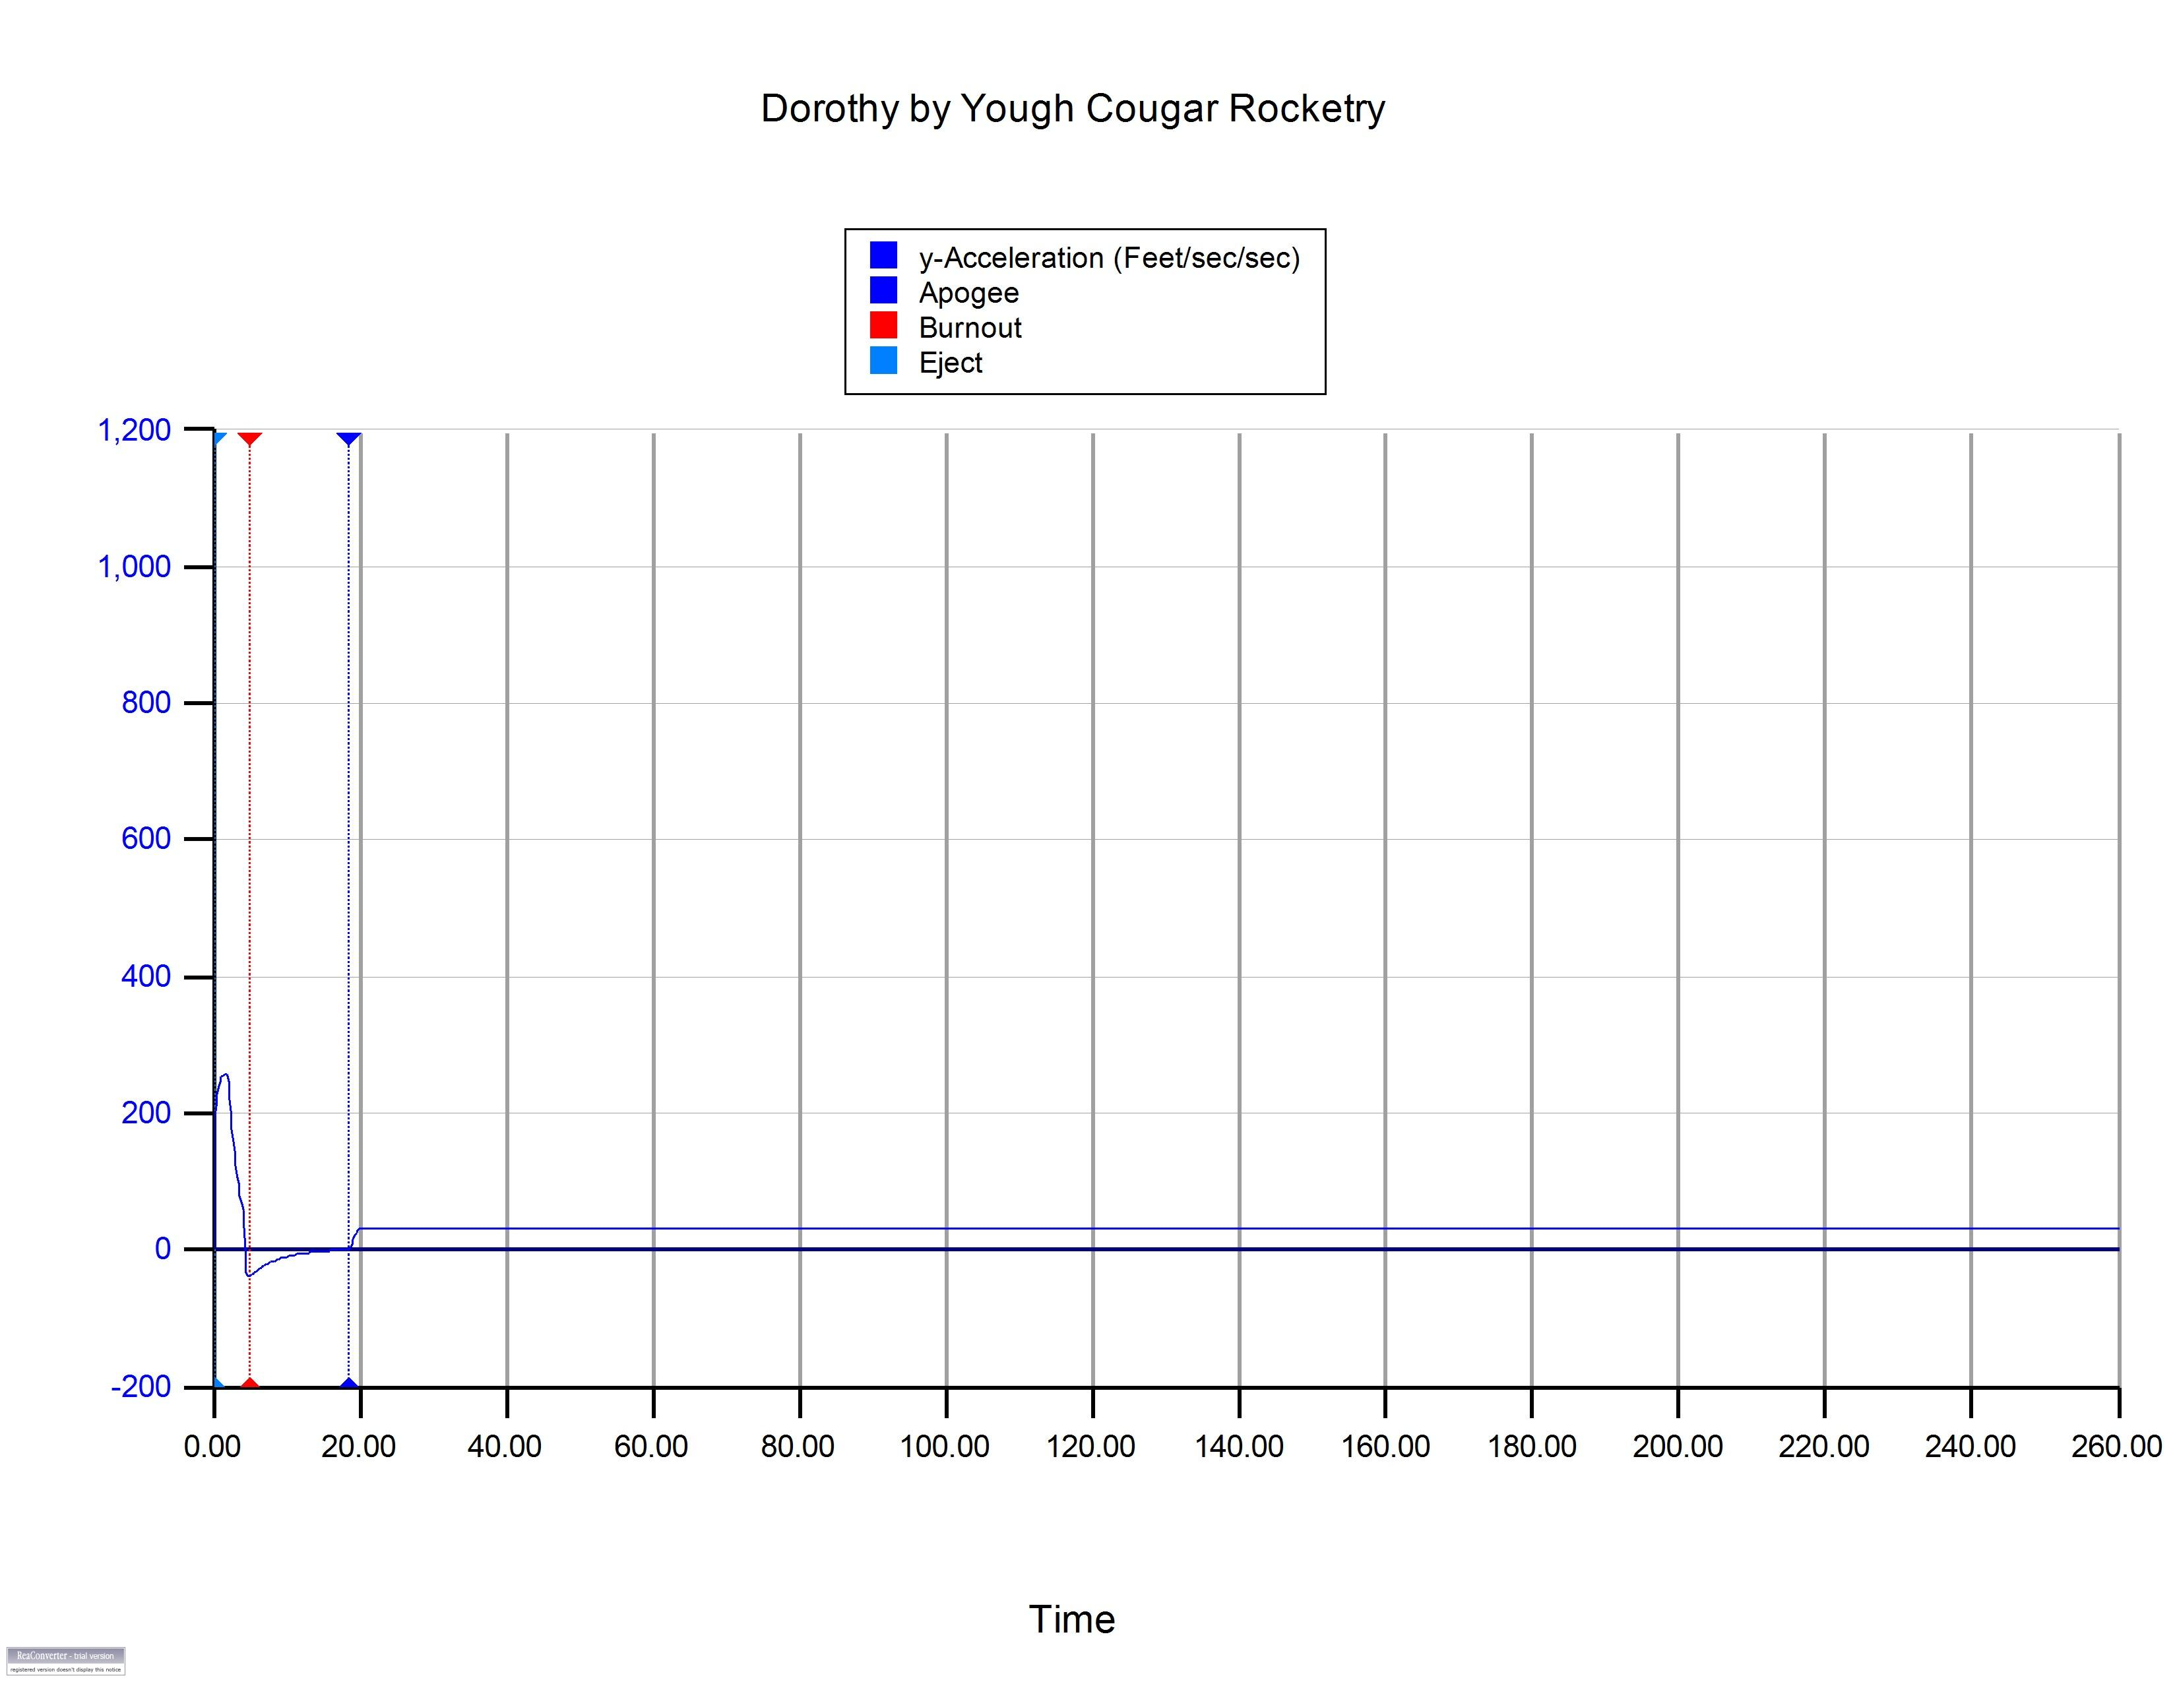

During the design phase of Dorothy, the team began to wonder if there was a possibility of attaining the speed of sound during the launch. The RockSim predictions fall short of the needed 741 miles per hour mark, which at maximum velocity of 621 feet per second, converts to 423.4 miles per hour. The team never intended to reach Mach; however, the thought of accomplishing this value was a desire. Below is the RockSim plot for velocity.

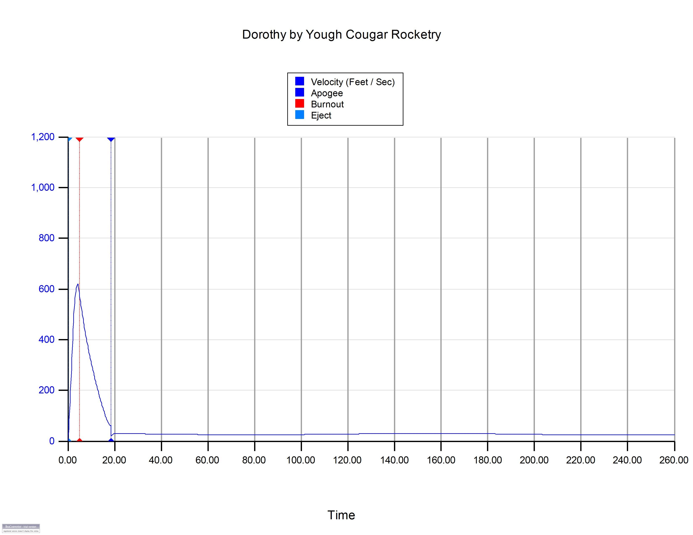
Review the Design at System Level

The following subsystems must be examined to ensure successful flight: Animal Motor Works K560 motor; PerfectFlite dual deployment altimeter; Pyrodex ejection charge system; drogue parachute; main parachute; whirly birds; shock cords; Kevlar reinforcing cords; and attaching hardware.

Dorothy Parts List

Quantity | Part Number | Item Description | Supplier
2 | 3.9 x 4.025 | 4 inch x 4 foot glass tube | Wildman
60 |  | Kevlar shock cord | Apogee
1 | FCT-4.0 | 4 inch coupler | Wildman
3 |  | 4 inch bulkplate airframe | Wildman
2 |  | 4 inch bulkplate couplers | Wildman
4 | CR-3.90-3.00 | 4 inch to 3 inch centering rings | Wildman
1 | FIN-2SQFT-125 | Sheet of 12" x 24" x 1/8" G10 | Wildman
1 | FIN-2SQFT-187 | Sheet of 12" x 24" x 3/16" G10 | Wildman
1 | FNC-4-5-1O | Ogive Nose cone 4" glass 5:1 | Wildman
1 | 94648A340 | Bag of 25 Press in Captive Nuts 8-32 | McMaster Carr
1 | 92949A192 | Box of 8-32 x 3/8" SS button head screws | McMaster Carr
2 | 7618K618 | Terminal Block Strips - Small | McMaster Carr
3 | MWC-SW-2 | 2 Pole Rotary Switch | Missle Works
2 | MWC-BH-9 | 9 Volt Battery Holder | Missle Works
25 | 71335K51 | 22 / 2 gauge wire per foot | McMaster Carr
4 |  | 1/4" SS U Bolts | Lowes
1 | 91841A029 | SS Nuts 1/4" – 20 | McMaster Carr
1 | 92146A029 | SS 1/4" - 20 Lock Washers | McMaster Carr
2 | 95853A111 | 1/4" -20 x 12" all thread | McMaster Carr
1 |  | 1/4" - 20 36" all thread | Lowes
1 | 90218A116 | .128" shear pins | McMaster Carr
6 | 3711T33 | Quick Links with large oval | McMaster Carr
1 | C 1/60 | Main Parachute | Wildman
1 | XT30 | 30" Drogue parachute | Wildman
2 | SWB8 | Ball Bearing Swivel Clips | Wildman
4 |  | 7.5" airframe chute protectors | Wildman
2 | LC800 | Perfectflite G-Wiz altimeter | Wildman
1 | MAWD | Perfectflite Main Altimeter | Perfectflite
Recovery Subsystems

A 60 inch Skyangle parachute has been selected as the main parachute for deployment at 800 feet. This diameter is within the specifications recommended by Wildman Rocketry for a 20 to 24 pound rocket. Dorothy’s current design estimates a weight of 20 pounds, well within the limitations of the parachute selected. An 18 inch drogue parachute is being used for the apogee deployment. The originally selected design was a Top-Flite Nylon Rip-Stop X-Flite. After examining the parachute, Mr. Walters believes that stronger lines are needed. Further examination of this drogue will be done and possibly changed before launch.

The attachment system used in Dorothy is by stainless steel braided cables, U-bolts, quick threaded connectors, and Kevlar shock cord. The stainless steel braided cables are connected through the centering rings of the motor mount in three locations. Previous tests with this design by Eric Haberman have resulted in no failures to date. The team believes highly in this design and the capability of Mr. Haberman. Connection of the tube coupler is via these cables. Another cable connects the upper section of the coupler, which holds the electronics, to the nose cone using a threaded quick connector at each end.

Deployment of the four ejection charges is being handled by a G-Wiz Deluxe LC – 800 logging altimeter. Firing of the four E-matches will be done at Apogee ( 2 E-matches firing ) for the drogue parachute and at 800 feet ( 2 more E-matches ) for the main parachute. These E-matches will be hot glued into used 18 millimeter Estes motor casings which hold the 4F black powder. This system has been in use by Mr. Ernie Walters for several years. Bench testing is scheduled to be completed of this system once the electronics have been mounted to the electronics board in the tube coupler.

Safety and Failure Analysis of Recovery Subsystems

Parachute not deploying | Deployment charge not igniting | Dangerous Landing | Bench test and Redundant System
Electronics bay malfunction | Loss of power to electronics  Faulty electronics | Ejection not occurring | Bench test and Redundant System
Parachute Detachment | Malfunction of shock cords, cables, etc; and attachment | Parachute and rocket separation not occurring and possibly a dangerous landing situation | Inspect all parts for damage
Shear pins not shearing | Not enough pressure applied from ejection | Parachute not deploying and possible crash landing | Bench test and analyze
Mission Performance Predictions

Mission success is to be determined if 75% of the expelled whirly birds are recovered and tagged. The whirly birds are to be released at two altitudes during the descent of the launch vehicle. At approximately 5000 feet, the drogue parachute will deploy and the first set of whirly birds will begin to fall toward the ground. When the launch vehicle reaches approximately 800 feet, the main parachute will deploy and another ( smaller ) set of whirly birds will be released.

Altitude predictions using the Animal Motor Works K560 motor can be found in the Vehicle Design section of this report along with thrust curves and velocity predictions. The whirly birds are not an electronic device and therefore have no sensitivity levels to control or adjust.

Each whirly bird has approximately twice the drag as a standard paint ball. Preliminary tests indicate that a falling paintball released from 29 feet above ground level traveled on average 1.4 seconds. In contrast, the whirly bird with an 18 inch tail had an average elapsed time of 3.5 seconds. These results show that the whirly bird falls 2.5 times slower than the paintball alone.

RockSim has calculated that the center of gravity is over three calibers above the center of pressure. This level of stability far exceeds the recommended two calibers for large scale rockets. During testing of the ¼ scale model, the rocket climbed purely vertical even in a moderately strong wind. These calculations and test flights have verified that Dorothy will indeed be very stable in flight.
Timeline and Objectives

The mission statement of the Yough High School Rocketry Team is to launch a high power rocket capable of carrying a scientific payload to an above ground altitude of one mile and successfully retrieving the payload as per specifications designated by the National Aeronautics and Space Administration. The Milestones schedule is as follows:

September 2006:
15th – Have the proposal completed in rough draft form
22nd – Have the proposal in completed form
25th – Mail proposal, no later than, September 29th
29th – Send e-mail and hard copy of proposal
( ALL September Milestones Complete )

October 2006:
18th – Begin writing the Preliminary Design Review (PDR)
18th – Begin building the quarter scale rocket
27th – Begin Website construction to be completed by, no later than, November 13th
27th – Outreach program 7:30 a.m. to 12:00 noon
( All October Milestones Complete )
( Website done ahead of schedule )

November 2006:
1st – Have PDR rough draft completed
8th – Have PDR final copy completed
9th – Submit first PDR report to Dawn Mercer, no later than, November 20th
27th – Have a PDR discussion
( All November Milestones Complete )
( PDR discussion in form of email from Julie Clift )

December 2006:
8th – Quarter scale rocket is complete
20th – Test launch quarter scale rocket, by this date
( All December Milestones Complete, test launch delayed until 1/4/07 )
( Extra meeting held on 12/28/06 with Ernie Walters )

January 2007:
3rd – Begin to finalize the second Critical Design Review (CDR) and Slides
16th – Begin construction on the full-scale rocket
22nd – Have CDR Presentation Slides and CDR report submitted to Dawn Mercer.
22nd – Critical Design Review and submit invoice
( Full Scale construction delayed due to shipment delay )

February 2007:
21st – Meeting with Earnest Walters and Eric to review launch vehicle construction
28th – Flight Readiness Review (FRR) rough draft completed
( Rough Draft complete ahead of schedule )

March 2007:
7th – Assemble fins into main airframe slots cut by Eric
19th – Have the FRR completed, posted to web site and/or mailed to Dawn Mercer
21st – Submit invoice

April 2007:
5th – Have the full-scale rocket completed in form
11th – Ship full-scale rocket to MSFC, AL
25th – Travel to Huntsville, AL
26th – Rocket Fair
27th – Launch Day
29th – Travel Home

May 2007:
14th – Have final rough draft report completed
21st – Have final report submitted and submit the invoice, no later than, May 25th

Scale Rocket Tests

On January 4, 2007, a launch of the ¼ scale launch vehicle was conducted with great success. The projected date for this test launch of December 20, 2006 had to be delayed for weather reasons and the holiday break. The scale launch vehicle was flown using a Quest A6-5 motor to unsure safe recovery and test rocket stability under low thrust conditions. The rocket tracked true and coasted vertically with almost no yaw until the speed was nearly zero. At that point, the rocket rolled gently and began to descend just as the ejection charge deployed. A six foot plastic tape streamer was used as the recovery device. The rocket landed fin first into the soft ground with no damage.

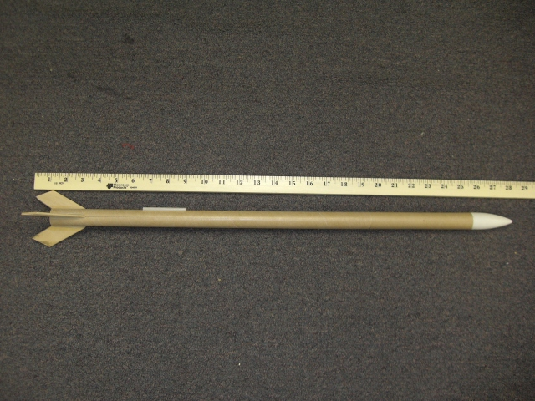

On January 11, 2007, another launch of the ¼ scale vehicle was conducted to test the flight pattern of the whirly bird. One whirly bird was loaded into the 0.976 inch airframe along with a paintball without a streamer. The launch was videotaped in order to use the timer to measure the difference in landing times of the two projectiles. The whirly bird had two three foot tails, an increase from the proposed twelve inch tail as preliminary testing showed that the twelve inch tail did not provide sufficient drag to catch the wind. The test was a success with the whirly bird landing eight ( 8 ) seconds after the paintball from an altitude of 64 feet. A Quest A6-4 motor was used to keep the altitude low. Calculations indicate that the whirly bird has a descent rate of 1.28 feet per second squared. This value will be used in further testing and to predict landing patterns of higher altitude flights.

Tests continued on the whirly bird pods on March 13, 2007. Several whirly birds were released from the bleachers at a height of 29 feet 3 inches. The drops were timed using stopwatches from the point of release to impact with the ground. The average time for these drops was approximately 3.30 seconds in the 8 – 10 mile per hour winds. The resulting flight paths were totally unexpected. During the vertical fall of about 29 feet, the whirly bird traveled a horizontal distance of no less than 27 feet and no greater than 57 feet from the drop point. Calculations made showed that the average horizontal distance was approximately 47 feet from the drop point. If the conditions on the day of the launch were similar to the testing circumstances, then the whirly birds would travel nearly 8557 feet ( over 1 ½ miles ) away from the launch point on the ground. This horizontal distance is much greater than desired. At the current time, the crepe paper tail of the whirly bird is three feet and is creating too much drag resulting in a significantly increased horizontal displacement. The original design was to have a crepe paper tail of eighteen inches. An increase in tail length was made to allow for better visibility. At the current time, a return to the original design must be made to ensure that the payload will land within a reasonable distance from the launch site.

Payload Integration

The payload will be placed into a fireproof bag, which will be attached to the Kevlar shock cord. This bag will be placed in the airframe in the payload sections and will open releasing the whirly bird contents upon ejection of the drogue parachute and the main parachute. The drogue parachute is scheduled to deploy at 5000 feet above ground level and the main parachute deploy at 800 feet above ground level to ensure safe recovery of the launch vehicle. The deployment bags will be folded and placed into the airframe such that the open end is upward. This allows the payload bag to begin opening upon making contact with the outside air after ejection and turning inside out by the tug of the shock cord therefore deploying all of the whirly bird contents.

Pre-Flight Procedures and Designated Inspectors

Whirly Bird Payload Assembly
Assembly Step | Assembly Personnel | Assembly Verification
Unpack paintballs from container and split into quantities of 75 and 25 | Ashley Wiley | Amy Bickerstaff
Cut streamer material into six foot lengths  Two separate colors for each payload | Amy Bickerstaff | Alicia Bowser
Paintball placed in center of streamer, folded over and taped in place | Ashley Wiley | Amy Bickerstaff  Alicia Bowser
Roll streamer material for compact fit into payload pouch | Alicia Bowser  Amy Bickerstaff | Ashley Wiley
Place whirly birds into payload pouch in an organized fashion | Alicia Bower  Amy Bickerstaff | Ashley Wiley
Fold payload pouch for insertion into the launch vehicle | Ashley Wiley | Earnest Walters  Tony Barbera

Launch Vehicle Preparation and Assembly
Assembly Step | Assembly Personnel | Assembly Verification
Assemble Animal Motor Works K560 | Earnest Walters | Tony Barbera
Install K560 into launch vehicle airframe | Earnest Walters | Tony Barbera
Secure K560 using latching system | Earnest Walters | Tony Barbera  Donald L. Gilbert, Jr.
Verify battery levels | Tony Barbera | Donald L. Gilbert, Jr.
Check that all wiring is secure and undamaged | Tony Barbera | Earnest Walters
Verify the systems are UNARMED | Tony Barbera | Earnest Walters  Donald L. Gilbert, Jr.
Assemble ejection charge packets  ( High Risk – Use Extreme Caution ) | Earnest Walters | Tony Barbera
Place ejection charges into launch vehicle | Earnest Walters | Tony Barbera
Run wiring through launch vehicle to electronics bay | Tony Barbera | Earnest Walters  Donald L. Gilbert, Jr.
Verify the ejection systems are UNARMED | Tony Barbera | Earnest Walters  Donald L. Gilbert, Jr.
Connect ejection charge wiring to altimeter ejection charge connections | Tony Barbera | Earnest Walters  Donald L. Gilbert, Jr.
Insert batteries into holders of the electronics bay | Tony Barbera | Earnest Walters
Verify all connections | Tony Barbera | Earnest Walters
Signal the “ALL CLEAR” | Tony Barbera | Range Safety Officer
Arm ejection systems to verify continuity of systems via LED lights | Tony Barbera  Earnest Walters | Donald L. Gilbert, Jr.
DISARM ejection systems | Tony Barbera | Earnest Walters
Verify all connections before inserting payload pouches | Tony Barbera | Earnest Walters  Donald L. Gilbert, Jr.

Final Assembly
Assembly Step | Assembly Personnel | Assembly Verification
Attach payload pouches to shock cords | Alicia Bowser  Amy Bickerstaff | Tony Barbera
Insert payload pouches into the launch vehicle airframe | Amy Bickerstaff | Tony Barbera  Earnest Walters
Verify that payload does not interfere with the ejection charge wiring | Tony Barbera | Earnest Walters
Insert electronics bay ( tube coupler ) into lower main body of launch vehicle using QuickLinks | Tony Barbera  Alicia Bowser | Earnest Walters
Insert nose cone into upper payload section of the launch vehicle airframe using QuickLinks | Tony Barbera  Alicia Bowser | Earnest Walters
Check for any binding of the nose cone or tube coupler that would prevent separation | Ashley Wiley | Earnest Walters  Tony Barbera
Perform continuity check of igniter | Tony Barbera | Earnest Walters
Insert igniter into K560 motor | Earnest Walters | Range Safety Officer
Slide launch vehicle onto launch rail | Tony Barbera  Donald L. Gilbert, Jr. | Earnest Walters  Range Safety Officer
General inspection of launch vehicle | Tony Barbera  Alicia Bowser  Amy Bickerstaff  Ashley Wiley | Earnest Walters  Donald L. Gilbert, Jr.  Range Safety Officer
Obtain permission to connect igniter | Donald L. Gilbert, Jr. | Earnest Walters
Verify all spectators are clear of the launch pad and are at a safe distance | Amy Bickerstaff  Alicia Bowser | Ashley Wiley
Connect igniter to launch system | Earnest Walters  Tony Barbera | Donald L. Gilbert, Jr.  Range Safety Officer
Obtain permission for launch | Donald L. Gilbert, Jr. | Earnest Walters
Signal the intention to launch | Donald L. Gilbert, Jr.  Tony Barbera | Earnest Walters
Verify all spectators are aware of launch countdown | Amy Bickerstaff  Alicia Bowser | Ashley Wiley  Range Safety Officer
Continue countdown | Tony Barbera | Earnest Walters
LAUNCH | Name drawn from hat | Range Safety Officer

Recovery Operations
Recovery Step | Recovery Personnel | Recovery Verification
Track flight path of launch vehicle to apogee and ejection | All Team members | All Team members
Track first whirly bird payload to ground | Alicia Bowser | Amy Bickerstaff
Track second whirly bird payload to ground | Ashley Wiley | Tony Barbera
Track flight path of launch vehicle to landing | Donald L. Gilbert, Jr. | Earnest Walters
Measure locations of whirly bird landing sites using GPS device | Tony Barbera | Ashley Wiley  Alicia Bowser  Amy Bickerstaff
Recover launch vehicle | Donald L. Gilbert, Jr. | Earnest Walters
Recover any loose parts if necessary | Donald L. Gilbert, Jr. | Earnest Walters

General Launch Operations Procedures as per Tripoli Safety Code

Nose Cone, Couplers – Ensure proper fit of nose cone and payload couplers

Flight Check (Safety Officer)

Construction Check – Ensure that the launch vehicle is well constructed with no loose parts
Safety Officer may wish to question any part of the construction with team members

Certification – Check the credentials of the team to certify a level II or greater member

Flight Plan

Check that the motor has sufficient impulse for safe launch
Ensure flight will not exceed the waiver limits issued by the F.A.A.
Verify recovery devices are in place and have been tested
Check that cloud ceilings are above maximum altitude capabilities
Calculate for variation of drift due to wind
Check that the rocket is stable by the locations of the CG and CP

Motor Installation

Verify that the motor is securely mounted in the airframe
Check that the igniters are free from cracks or lack pyrogen tip

Avionics

Arm ejection charge on launch pad ONLY
Check continuity of igniter once all spectators are away from launch pad

Pad Check (RSO or Pad Manager)

Controller – Check and be sure that the rocket is disarmed before approaching launch pad
Launch Pad – Check for stability and adequate size for rocket to be flown
Ensure that spectators are at the minimum safe distance for motor impulse
Launch Rod or Guides – Check that rocket slides freely, clean if necessary
Igniter Clips – Check and clean the leads

Pre Launch Check (RSO)

Avionics – Armed and ready for launch
Look and Listen – Check for aircraft in the launch area. Stop launch for incoming aircraft
Flight Witnesses and Spotters – Present and made aware prior to launch

Launch (LCO)

Announce Launch
Ensure all spectators are aware of the launch
Provide a LOUD countdown such as 5, 4, 3, 2, 1 … Fire!
Monitor Flight Path – Yell “HEADS UP” for any rocket approaching any area with spectators
Disarm controller, place cap on launch rod after launch

Misfire Procedures (LCO)

Wait a minimum of one minute before approaching launch pad
Disarm launch controller and avionics if present
Remove failed igniter and motor if necessary
Replace igniter and follow launch procedures

Safety and Environment (Vehicle Criteria)

Tony Barbera is our Safety Officer for our team.

If an object were to fall off the rocket or doesn’t work as designed, the situation would be managed as follows:

Fins- A rocket fin could fall off and the rocket could possibly fly uncontrollably in any direction without planning. All spectators and launch crew are to watch the launch vehicle at all times and have an escape route planned.

Motor and Parachute- If the motor doesn’t fire properly, the following scenarios could occur:
- The motor does not have enough thrust and therefore the rocket might not reach its desired altitude or yaw off course.
2. Rocket could tip over and come down uncontrollably and hit the ground with immense speed and flutter around the ground or spread debris.
3. If the motor does not give enough thrust, the parachute deployment could alter or fail.
4. If the parachute deployment is altered by motor malfunction, the parachute may not deploy; therefore, resulting in the rocket to fall uncontrollably and impacting the ground at high speed and spread debris.

Personal Hazards:

Fiberglass in the eyes means: wear safety goggles to prevent any thing happening
Sawdust in the eyes means: wear safety goggles to prevent anything happening
Burns on skin from motors or preventing fiberglass cuts means: wear safety gloves and body protectors to cover and protect the areas where skin shows to prevent
Headaches from fumes of paint means: wear a breathing mask to cover the mouth and face to prevent inhalation of fumes, and to also paint in well ventilated area, such as a paint booth
Tripping over wires: tape wires down to the ground, and if trippage occurs, you should check for cuts and bruises to bandage and sanitize the areas injured
First Aid must: You should always have a first aid kit handy at all times in case injury does occur
Projectiles: You must get far enough distance away from any object being flown that is required by law, and get under some type of covering, such as a roof
Cutting or Painting: A respirator will be used to filter all particulates in the air to prevent lung and health damage.

Before the rocket launches
- Eliminate all possibilities by installing devices of importance incorrectly
- Eliminate all possibilities to accidentally launch before everyone is safely behind safety shield or standing at a safe distance
- Eliminate all possibilities to have anyone approach the rocket and cause injury to one’s self or the launch vehicle

To prevent such things from happening
- Have more than one person overlooking preparation of launch vehicle assembly
- Make sure that everyone is behind a safety shield or a safe distance from the launch pad as designated by the RSO before someone arms or launches the rocket
- Ensure that all personnel inside the launch area are aware of all activities and have necessary safety gear and emergency escape routes
- Have the launch vehicle in a secure area

During the rocket launch
1. During the launch, the launch vehicle could be lost if no one is tracking its path visually from the ground.
2. The launch vehicle could break apart or encounter an electronic malfunction resulting in catastrophic system failure causing multiple fiberglass fragments falling downward to the launch or spectator area.

To prevent such things from happening
- Have more than one person watching the rocket and pin-pointing a location for landing
- Watch the rocket at all times if debris falls from the launch vehicle. The person identifying any debris is to track its path to the ground and recover once the RSO has designated the area safe

Environmental Concerns

If the rocket catches on fire then
- Wild-fire can occur if grass is dry enough
- Scorching of area around rocket can occur if the grass is damp
- Debris which is not recovered could be ingested by animals
- Debris which is not recovered could damage vehicles or machinery traveling through the area
- Debris which is not recovered could harm the local ecosystem

Things to do to prevent such things from happening

When possible, use biodegradable materials to reduce environmental harm and assign specific personnel to track debris if required.

II. Payload Criteria

Selection, Design, and Verification of Payload Experiment
The design of a whirly bird is to mimic the maple tree seedpod found in nature.

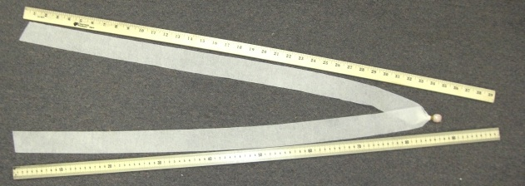

The system level components of the payload section include:

Altimeter- Designed to release the ejection charges at designated altitudes, and deploy whirly bird payload
Payload- Designed to deploy the whirly-birds at set intervals in order to free fall to the ground to be mapped in order to determine the distance from the launch pad
Ejection charge- Made to deploy the payload and the parachute to initiate recovery of the launch vehicle and send whirly birds into free fall
Air frame- keeps the rocket in tact by creating a rigid exterior that has solid structure (exoskeletons)

No drawing of the whirly bird has been made; please refer to the picture on the previous page. The whirly bird has an overall length of approximately 18 inches. This dimension will actually be about one to two inches shorter as the paint ball will be wrapped into the 39 inch pieces of crepe paper streamer which is folded in half.

Preliminary analysis of the descent rate of the whirly bird will be determined using a grid sheet marked in feet and inches. A team member will then videotape a whirly bird as it is dropped to measure time and displacement. The equation
$y=\frac{1}{2}{\text{at}}^{2}$ and solving for the acceleration yielded $a=\frac{2y}{t^{2}}$. As the whirly bird dropped, its path could be seen on the video and the time was measured from the camera counter. This process is the same as is used in the Discovery Channel television show, Mythbusters. The video has been created, however the analysis of the video has not yet been completed. A video clip of the drop is provided in the PowerPoint.

A similar test to find the acceleration of the whirly bird was done by placing a whirly bird inside of the ¼ scale launch vehicle and a paintball without any crepe paper attached. The rocket was launched and videotaped. Once again, the camera timer was used to determine the time for the equations. From the video, the rocket reached apogee at 64 feet. The paintball can be heard impacting the football field. The difference in time was 2 seconds, yielding the 64 foot altitude at ejection using $y=\frac{1}{2}{\text{at}}^{2}$ and 32 feet per second squared as the acceleration of gravity. The whirly bird landed 10 seconds after ejection. Using $a=\frac{2y}{t^{2}}$ and the 64 feet as the vertical displacement, the acceleration of the whirly bird was found to be 1.28 feet per second squared. Due to the amount of streamer material for each whirly bird, it has been determined that the payload will reach terminal velocity almost immediately upon ejection. Therefore, the acceleration of the whirly bird can be considered constant throughout the flight path.

The integrity of the design is solid. Since there are no mechanical parts or electronic devices to make up the whirly bird itself, the probability of a malfunction are highly limited. During a test of the whirly bird being ejected from a rocket, it was noted that some of the crepe paper became scorched. It is believed that this may decrease the amount of drag on the whirly bird in flight, but to what extent, the team has been unable to measure since the amount of burnt crepe paper cannot be predicted. Therefore, it is the goal to provide a flame free environment for the whirly bird at all times to eliminate the scorching effect.

A demonstration of the whirly bird in flight can be viewed in the CDR PowerPoint presentation found on the website.

The success of the mission hinges on the fact that all the whirly bird pods must be of the same length and mass. In order to ensure that each whirly bird is the same, Amy Bickerstaff will cut each crepe paper streamer to the same length. Ashley Wiley will wrap each paintball. Alicia Bowser and Amy Bickerstaff will fold and roll each whirly bird and place into a storage container. Tony Barbera will then load the payload into the launch vehicle prior to launch.

The materials to construct the launch vehicle arrived from the various sources on or about February 7, 2007. Plans for construction of the rocket are to compile all of the parts at Mr. Gilbert’s home and begin construction after school when possible and during Saturdays. The fiberglass pieces were sent out for the fins to be cut and beveled. The body tubes were also sent to have slots cut for the fins tabs to fit into and necessary holes drilled for venting and plastic rivet insertion. Mr. Ernie Walters provided a rough drawing of the electronics board wiring schematic.

The teams’ integration plan includes the following known details:

1. Provide Mr. Ernie Walters with the G10 material to be cut for fins and beveled by Mr. Eric Haberman
2. Begin construction of the electronics bay
3. Assemble bulkheads to create electronics bay
4. Install motor mount assemble provided by Mr. Ernie Walters
5. Install and epoxy fins upon return from Mr. Walters and Mr. Haberman
6. Install hardware for attachment of shock cord and parachutes
7. Attach launch rail buttons
8. Mask off rail buttons and sand smooth the body tubes
9. Apply primer and paint launch vehicle
10. Apply decals

The Instrumentation used in Dorothy includes the G-Wiz LC 800 altimeter. For the specifications about this device, please refer to the document LC800 in PDF format.

Safety concerns for the individual whirly birds are very low. Since they are a low mass object and have a high coefficient of drag, they descend at a very low rate. In the event that a person is not aware that a whirly bird is about to impact them, there would be no injury to that person. Failure concerns could result in the whirly bird falling at a high descent rate and therefore include possible injury. A failure would result if the crepe paper streamer did not unroll resulting in a lower drag coefficient and therefore a higher descent rate.

Experiment Concept:

The scientific payload uses objects that are not technologically advanced. The whirly birds are made up of crepe paper and a small paintball.

The uniqueness of this payload is that the objects we use could be found with ease. The significance of this project is to determine if ground level wind speeds are the same as wind speeds at an altitude of one mile. These predictions could assist aviation related fields.
The suitable level of challenge is medium to medium high. The team has experience in building small rockets and even clustered motors; however, the use of high power materials in a new experience. There will definitely be challenges for the team, but we are ready to work diligently.

Science Value:

The scientific payload objectives show us how wind thermals circulate objects around the troposphere. Examples of such objects could include, but are not limited to, pollen, seeds, dust and debris from forest fires or volcanoes and even possible radiation fallout. Our objective is to recover 75% of the ejected whirly birds and mark their location on a topographical map with the assistance of Global Positioning System (GPS) resources.

Hypothesis: Ground level wind speed is the same from ground level up to 5280 feet above ground level.

Prediction: Whirly birds dropped from two release points will land within a specific location based on calculations if the wind velocity remains constant during free fall.

Assumptions: The whirly birds will reach terminal velocity immediately upon ejection from the payload section of the launch vehicle, thus resulting in the elimination of gravity into the equations.

The main variable for this launch is the wind.

The relevance of expected data can be found on pages below.( the charts )

Whirly Bird Payload Assembly
Assembly Step | Assembly Personnel | Assembly Verification
Unpack paintballs from container and split into quantities of 75 and 25 | Ashley Wiley | Amy Bickerstaff
Cut streamer material into six foot lengths  Two separate colors for each payload | Amy Bickerstaff | Alicia Bowser
Paintball placed in center of streamer, folded over and taped in place | Ashley Wiley | Amy Bickerstaff  Alicia Bowser
Roll streamer material for compact fit into payload pouch | Alicia Bowser  Amy Bickerstaff | Ashley Wiley
Place whirly birds into payload pouch in an organized fashion | Alicia Bower  Amy Bickerstaff | Ashley Wiley
Fold payload pouch for insertion into the launch vehicle | Ashley Wiley | Earnest Walters  Tony Barbera

Possible Graphical Scenarios

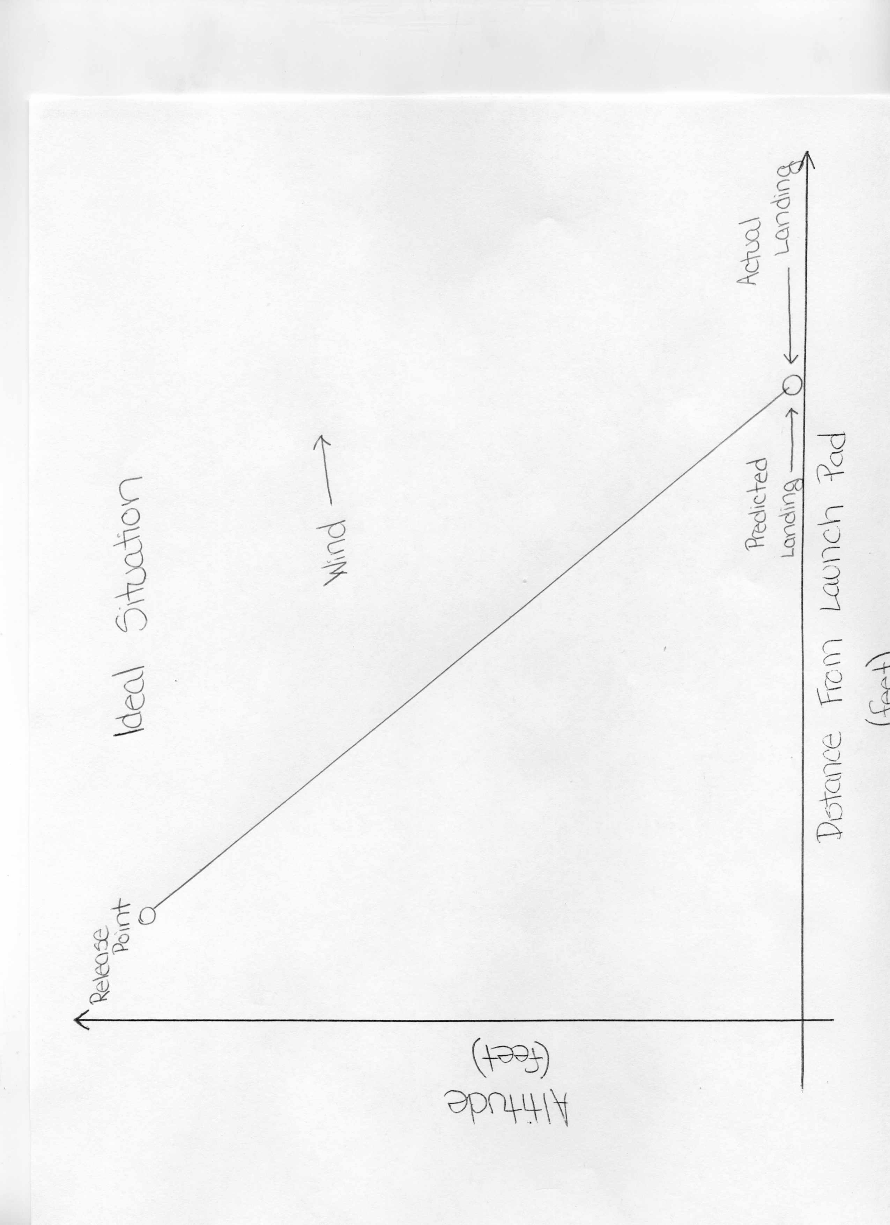
Possible Graphical Scenarios

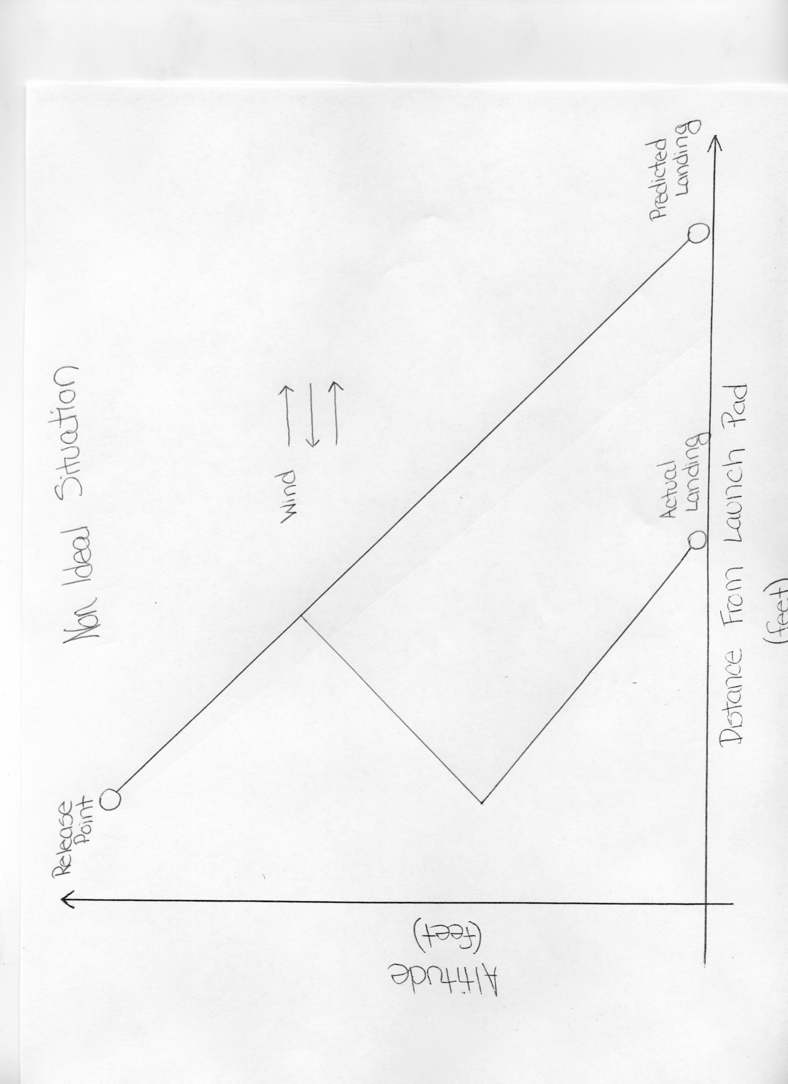

Possible Graphical Scenarios

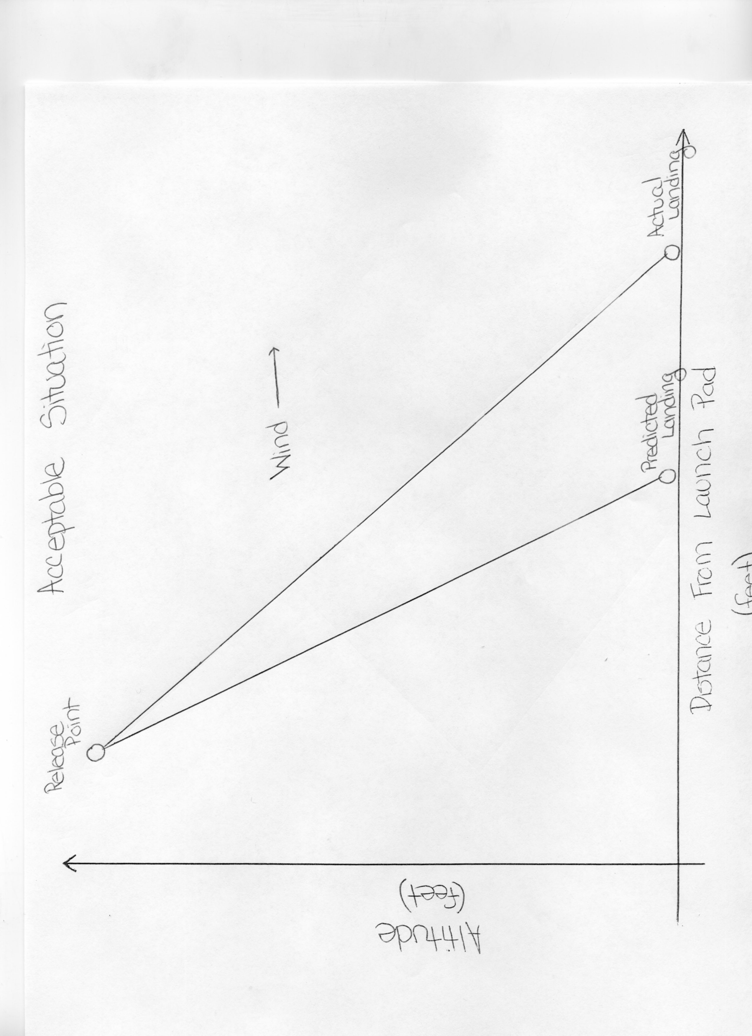

The scientific hypothesis of our experiment is to determine if the surface level winds are an accurate predictor of wind speed at an altitude of 5,280 feet (1 mile). Using the topographical map and GPS locations, the horizontal distance can be determined. Physics equations can then be utilized to calculate the average wind speed experienced by the whirly bird. These values can then be compared to the predicted values before launch. Statistical calculations will then be compared to determine if there is sufficient evidence to support or refute the hypothesis.

In order to find the time of the drop for the whirly birds, the altitude at ejection will be retrieved from the altimeter. This value will then be used to calculate the time using distance = rate * time. Making the assumption that the payload will be ejected at 5280 feet and 800 feet, the time to reach the ground on a perfectly still day would be 637 seconds and 96 seconds respectively using the descent rate at a constant 8.28 feet per second. To calculate the horizontal displacement, the use of d = rt is once again utilized. This time, the rate will be the wind speed measured in MPH then converted to feet / sec for calculations. The table shows estimated displacements from the launch pad based on varying speeds of the ground level winds.

If the calculated distance differs from the actual distance to the landing of the whirly birds, then the above situations will be examined to determine which is the most feasible for analysis. Once all data is collected, then the process of interpreting the data can be completed for final analysis and interpretation.
Estimated Displacement from Launch pad of Whirly Birds

Wind | Wind | Estimated Horizontal Displacement from Apogee | Estimated Horizontal Displacement from Main Chute Ejection
MPH | Feet / sec | Feet | Feet
0.5 | 0.733 | 467.13 | 70.40
1.0 | 1.467 | 934.27 | 140.80
1.5 | 2.200 | 1401.40 | 211.20
2.0 | 2.933 | 1868.53 | 281.60
2.5 | 3.667 | 2335.67 | 352.00
3.0 | 4.400 | 2802.80 | 422.40
3.5 | 5.133 | 3269.93 | 492.80
4.0 | 5.867 | 3737.07 | 563.20
4.5 | 6.600 | 4204.20 | 633.60
5.0 | 7.333 | 4671.33 | 704.00
5.5 | 8.067 | 5138.47 | 774.40
6.0 | 8.800 | 5605.60 | 844.80
6.5 | 9.533 | 6072.73 | 915.20
7.0 | 10.267 | 6539.87 | 985.60
7.5 | 11.000 | 7007.00 | 1056.00
8.0 | 11.733 | 7474.13 | 1126.40
8.5 | 12.467 | 7941.27 | 1196.80
9.0 | 13.200 | 8408.40 | 1267.20
9.5 | 13.933 | 8875.53 | 1337.60
10.0 | 14.667 | 9342.67 | 1408.00
10.5 | 15.400 | 9809.80 | 1478.40
11.0 | 16.133 | 10276.93 | 1548.80
11.5 | 16.867 | 10744.07 | 1619.20
12.0 | 17.600 | 11211.20 | 1689.60
12.5 | 18.333 | 11678.33 | 1760.00
13.0 | 19.067 | 12145.47 | 1830.40
13.5 | 19.800 | 12612.60 | 1900.80
14.0 | 20.533 | 13079.73 | 1971.20
14.5 | 21.267 | 13546.87 | 2041.60
15.0 | 22.000 | 14014.00 | 2112.00

Experiment Design of Payload

Because the whirly birds are not electronically controlled, they require no calibration prior to launch. Since each whirly bird is made by hand, there is an uncertainty in the folding of each individual piece. It is therefore possible that each whirly bird may deviate slightly from others regarding flight characteristics. These deviations are not considered significant because the dispersion of the whirly bird group is expected to cover a radius of approximately 200 yards for the primary deployment and 50 yards for the secondary. At the current time, weather conditions have severely hampered any continued measurements for the whirly bird velocity testing. Once acceptable conditions are available, further testing will be conducted to test the repeatability of the payload.

Assembly

The variables for this experiment are time, wind speed, altitude of launch vehicle, and wind direction. The constants will be gravitational acceleration, mass of the whirly birds, and the coefficient of drag encountered by the whirly bird.
The experiment process procedures include:
  - Purchase a container of paintballs
  - Separate 100 paintballs into increments of 75 and 25
  - Cut six foot segments of crepe paper
  - Place one paintball in the center of each piece of crepe paper
  - Secure paintball using a rubber band and/or tape to create a whirly bird
  - Fold and roll crepe paper to within three inches of paintball
  - Secure whirly bird into a storage container
  - Remove whirly birds from storage container and pack into payload bag
  - Insert payload bag into payload section of launch vehicle
  - Payload is now ready for deployment

Safety and Environment (Payload Criteria)

Our Safety Officer for the Yough Rocketry Team is Anthony Barbera.

Before the rocket launches
1. Eliminate all possibilities to forget to install devices of importance incorrectly
2. Eliminate all possibilities to accidentally launch before everyone is safely behind safety shield
- Eliminate all possibilities to have anyone approach the rocket and cause injury to one’s self or the launch vehicle

To prevent such things from happening
1. Have more than one person overlooking preparation of launch vehicle assembly
2. Make sure that everyone is behind a safety shield or a safe distance from the launch pad as designated by the RSO before someone arms or launches the rocket
3. Ensure that all personnel inside the launch area are aware of all activities and have necessary safety gear and emergency escape routes
- Have the launch vehicle in a secure area

During the rocket launch
1. During the launch, the launch vehicle could be lost if no one is tracking its path visually from the ground.
2. The launch vehicle could break apart or encounter an electronic malfunction resulting in catastrophic system failure causing multiple fiberglass fragments falling downward to the launch or spectator area.

To prevent such things from happening
1. Have more than one person watching the rocket and pin-pointing a location for landing
2. Watch the rocket at all times if debris falls from the launch vehicle. The person identifying any debris is to track its path to the ground and recover once the RSO has designated the area safe

Environmental Concerns

If the rocket catches on fire then
1. Wild-fire can occur if grass is dry enough
2. Scorching of area around rocket can occur if grass damp
3. Debris which is not recovered could be ingested by animals
4. Debris which is not recovered could damage vehicles or machinery traveling through the area
- Debris which is not recovered could harm the local ecosystem

Things to do to prevent such things from happening

When possible, use biodegradable materials to reduce environmental harm and assign specific personnel to track debris if required.

Personal Hazards:

If there is a fire on or in the launch vehicle, the payload will not burn because the crate paper is flame resistant and the paint balls are flame retardant as per the manufactures descriptions.
The shock cord is Kevlar, which is not necessarily flame resistant, however flame retardant and could possibly scorch. Any scorching of the shock cord should not be sufficient to damage it to the point of separation resulting in separation of the parachute and airframe.

III. Launch operation procedures

Whirly Bird Payload Assembly
Assembly Step | Assembly Personnel | Assembly Verification | Check If Done
Unpack paintballs from container and split into quantities of 75 and 25 | Ashley Wiley | Amy Bickerstaff
Cut streamer material into six foot lengths  Two separate colors for each payload | Amy Bickerstaff | Alicia Bowser
Paintball placed in center of streamer, folded over and taped in place | Ashley Wiley | Amy Bickerstaff  Alicia Bowser
Roll streamer material for compact fit into payload pouch | Alicia Bowser  Amy Bickerstaff | Ashley Wiley
Place whirly birds into payload pouch in an organized fashion | Alicia Bower  Amy Bickerstaff | Ashley Wiley
Fold payload pouch for insertion into the launch vehicle | Ashley Wiley | Earnest Walters  Tony Barbera

Launch Vehicle Preparation and Assembly
Assembly Step | Assembly Personnel | Assembly Verification | Check If Done
Assemble Animal Motor Works K560 | Earnest Walters | Tony Barbera
Install K560 into launch vehicle airframe | Earnest Walters | Tony Barbera
Secure K560 using latching system | Earnest Walters | Tony Barbera  Donald L. Gilbert, Jr.
Verify battery levels | Tony Barbera | Donald L. Gilbert, Jr.
Check that all wiring is secure and undamaged | Tony Barbera | Earnest Walters
Verify the systems are UNARMED | Tony Barbera | Earnest Walters  Donald L. Gilbert, Jr.
Assemble ejection charge packets  ( High Risk – Use Extreme Caution ) | Earnest Walters | Tony Barbera
Place ejection charges into launch vehicle | Earnest Walters | Tony Barbera
Run wiring through launch vehicle to electronics bay | Tony Barbera | Earnest Walters  Donald L. Gilbert, Jr.
Verify the ejection systems are UNARMED | Tony Barbera | Earnest Walters  Donald L. Gilbert, Jr.
Connect ejection charge wiring to altimeter ejection charge connections | Tony Barbera | Earnest Walters  Donald L. Gilbert, Jr.
Insert batteries into holders of the electronics bay | Tony Barbera | Earnest Walters
Verify all connections | Tony Barbera | Earnest Walters
Signal the “ALL CLEAR” | Tony Barbera | Range Safety Officer
Arm ejection systems to verify continuity of systems via LED lights | Tony Barbera  Earnest Walters | Donald L. Gilbert, Jr.
DISARM ejection systems | Tony Barbera | Earnest Walters
Verify all connections before inserting payload pouches | Tony Barbera | Earnest Walters  Donald L. Gilbert, Jr.

Final Assembly:

Assembly Step | Assembly Personnel | Assembly Verification | Check If Done
Attach payload pouches to shock cords | Alicia Bowser  Amy Bickerstaff | Tony Barbera
Insert payload pouches into the launch vehicle airframe | Amy Bickerstaff | Tony Barbera  Earnest Walters
Verify that payload does not interfere with the ejection charge wiring | Tony Barbera | Earnest Walters
Insert electronics bay ( tube coupler ) into lower main body of launch vehicle using QuickLinks | Tony Barbera  Alicia Bowser | Earnest Walters
Insert nose cone into upper payload section of the launch vehicle airframe using QuickLinks | Tony Barbera  Alicia Bowser | Earnest Walters
Check for any binding of the nose cone or tube coupler that would prevent separation | Ashley Wiley | Earnest Walters  Tony Barbera
Perform continuity check of igniter | Tony Barbera | Earnest Walters
Insert igniter into K560 motor | Earnest Walters | Range Safety Officer
Slide launch vehicle onto launch rail | Tony Barbera  Donald L. Gilbert, Jr. | Earnest Walters  Range Safety Officer
General inspection of launch vehicle | Tony Barbera  Alicia Bowser  Amy Bickerstaff  Ashley Wiley | Earnest Walters  Donald L. Gilbert, Jr.  Range Safety Officer
Obtain permission to connect igniter | Donald L. Gilbert, Jr. | Earnest Walters
Verify all spectators are clear of the launch pad and are at a safe distance | Amy Bickerstaff  Alicia Bowser | Ashley Wiley
Connect igniter to launch system | Earnest Walters  Tony Barbera | Donald L. Gilbert, Jr.  Range Safety Officer
Obtain permission for launch | Donald L. Gilbert, Jr. | Earnest Walters
Signal the intention to launch | Donald L. Gilbert, Jr.  Tony Barbera | Earnest Walters
Verify all spectators are aware of launch countdown | Amy Bickerstaff  Alicia Bowser | Ashley Wiley  Range Safety Officer
Continue countdown | Tony Barbera | Earnest Walters
LAUNCH | Name drawn from hat | Range Safety Officer

Recovery Operations
Recovery Step | Recovery Personnel | Recovery Verification | Check If Done
Track flight path of launch vehicle to apogee and ejection | All Team members | All Team members
Track first whirly bird payload to ground | Alicia Bowser | Amy Bickerstaff
Track second whirly bird payload to ground | Ashley Wiley | Tony Barbera
Track flight path of launch vehicle to landing | Donald L. Gilbert, Jr. | Earnest Walters
Measure locations of whirly bird landing sites using GPS device | Tony Barbera | Ashley Wiley  Alicia Bowser  Amy Bickerstaff
Recover launch vehicle | Donald L. Gilbert, Jr. | Earnest Walters
Recover any loose parts if necessary | Donald L. Gilbert, Jr. | Earnest Walters

Safety and Quality Assurance

Everything that is in the payload is biodegradable. The risk of any payload particles falling down and making human is unlikely, but in the unfortunate event that a person would be in the proximity of a whirly bird, the lightweight design and low velocity should not result in any bodily damage. There might be a small chance of a paint ball bursting on impact, which would require washing the paint off thoroughly with soap and water. The attached cord that runs through the center of the payload should not break off and do any harm inflictions to the environment, but in case of a major mishap, yell “HEADS UP.”

To ensure the safety of all rocketeers, a check list listed above has been issued. When handling any materials used to make the rocket dealing with the payload section, mentors have been issued to watch each process.

Construction
- During the construction phase of the rocket, tiny particles of shrapnel of building materials could be expelled from the rocket without proper filtration.
- The happenings will be avoided by the use of proper facilities with the necessary filtration systems.
- The disposal of small shrapnel material should harm the surrounding environment, but as a precaution, preventing this from happening will be done by the proper use of disposing of these components.

Payload
- Every item in the payload is biodegradable, except for the fact that there is a stainless steel metal wire attaching the electronics bay to the nose cone.

Safety Officer
Tony Barbera is the main person responsible for maintaining safety, quality, and procedures checklist.

Outreach Program

The Yough Rocketry Team sponsored a teacher in-service on October 27, 2006 for 19 teachers from surrounding school districts to instruct them on rocketry programs for their schools. The team explained the Team America Rocketry Challenge and the NASA Student Launch Initiative. Informational packets provided by NASA’s Marshall Space and Flight Center’s Education Department were distributed showing the basics of rocket construction and flight equations. Supplementary packets were also downloaded from the internet from NASA’s website and distributed and reviewed with the teachers. The session concluded with the teachers construction the Quest Starhawk rocket kit guided by the students. Once the rockets were constructed, the teachers were taken outside and each launched their rockets. Some rockets were lost, most were not. The session was very well received by the teachers who attended.

A letter was received by the Mon Valley Education Consortium recently thanking the team for the program provided to the teachers. The feedback received from the surveys was very positive. Many teachers asked if the program would be expanded for next year. At this time, the Yough School District is unsure if any events will be hosted in the fall.

